Questions for Replace Coal Boilers
It is the VHA’s determination these plans, and specifications are generic as possible so that multiple bidders can fairly bid on this project. If there are requirements that may be perceived to negatively impact contractor’s ability to bid this project, provide specific requests for information to the VHA Contracting Officer
- Is location for the GC trailer also for dumpster and porta jon locations
See section 01 00 00 / Paragraph 1.6 (Operations and Storage Areas)
- The Contractor shall confine all operations (including storage of materials) on Government premises to areas authorized or approved by the Contracting Officer. The Contractor shall hold and save the Government, its officers and agents, free and harmless from liability of any nature occasioned by the Contractor's performance.
- Temporary buildings (e.g., storage sheds, shops, offices) and utilities may be erected by the Contractor only with the approval of the Contracting Officer and shall be built with labor and materials furnished by the Contractor without expense to the Government. The temporary buildings and utilities shall remain the property of the Contractor and shall be removed by the Contractor at its expense upon completion of the work. With the written consent of the Contracting Officer, the buildings and utilities may be abandoned and need not be removed.
- The Contractor shall, under regulations prescribed by the Contracting Officer, use only established roadways, or use temporary roadways constructed by the Contractor when and as authorized by the Contracting Officer. When materials are transported in prosecuting the work, vehicles shall not be loaded beyond the loading capacity recommended by the manufacturer of the vehicle or prescribed by any Federal, State, or local law or regulation. When it is necessary to cross curbs or sidewalks, the Contractor shall protect them from damage. The Contractor shall repair or pay for the repair of any damaged curbs, sidewalks, or roads.
- Working space and space available for storing materials shall be as determined by the COR.

- Per the solicitation it states that the Proposal requirement is Past Performance. Can the sub-contractor past performance be utilized in lieu of that of the GC due to the specific & limited requirement request?
No. Prime Past Performance only.
- Due to the location of the project and many sub-contractors having to travel, can a 3rd site visit be scheduled for these companies.
No other site visits are planned at this time.
- Can this bid be assembled and emailed into the COR at bid time with a hard copy to follow?
Proposals are to be emailed to the Contract Specialist listed in the solicitation. The proposals are due at the date and time in the solicitation. Any proposal received after that time will be considered late and not acceptable.
- Will the VA provide electrical temporary power capability to have connection to for their use in the GC trailer during the construction period
See section 01 00 00 – 18 / Paragraphs 1.18 (Temporary Use of Mechanical and Electrical Equipment) 1.22 (Availability and Use of Utility Services)

- Provide the sign in sheets from the Pre-bid walk through.
This will be provided in the next amendment.
- Has the building (construction site) been tested for presence of any hazardous materials (lead paint and/or ACM materials)? Per Specification 01 32 16.15-4 / D (page 4): The Contractor shall cost load work activities/events for all BID ITEMS including ASBESTOS ABATEMENT.
All suspected ACM and lead containing materials have been removed. If additional Material is suspected the contractor shall have the material tested. If positive, abatement procedures will be negotiated and conducted.

- Due to current durations and lead times, we have been informed by several boiler contractors and suppliers that lead time depending on order confirmation could exceed 5-6 months. We are requesting that there be a NTP for submittals and shop drawing review and approval with a 2nd NTP issued once Boiler systems are ordered and a fabrication timeframe is better established with project duration of 270 days starting once the boiler systems have a confirmation date of shipment
The schedule of the project shall be a total of 270 days. It was expected that the material delivery would be 6 months and construction would be 3 months. Material delivery time may be extended if requested.
- Can photos be provided from the site walk through of both the building interior and the project site. Provide clarification and if reports are available issue them accordingly
Some photos of the site have been provided. Any other photos should have been taken during the site visit.
- Provide clarification of Phase 3 work and what is to be included within the projects scope of work.
Phase 3 work not in contract.

- As shown on sheet C-001 it appears that the drawing shows fencing with gates surrounding building 90. Is this correct or are we to supply temporary fencing / gates around the site as shown on the sheet as Limit if Work?
Phase 3 work will not be a part of this project.
- Provide ICRA requirements specific to the project site
See Section 01 35 26 – 14 / Paragraph 1.12 “Infection Control” Items A-J

- Specifications call for metal framing / drywall however we cannot find any reference to these materials or their installation, provide clarification
Spec Section 092900-Gypsum Board: Metal Framing/ Drywall may be used to patch interior openings where approved by COR.
- Phase 3 as referenced. Provide clarification of extents of phase 3 as it interacts with this project
Repeat of Question 10 above.
- Confirm if this site going to be a “COVID-19 Vaccination Required” site
See Clause 52.223-99 Ensuring Adequate COVID-19 Safety Protocols for Federal Contractors below.
- Provide contact information for local utility company as called for.
This is a typically part of the GCs due diligence.

Sheet CD101
- Coded note 2. Provide thickness of concrete to be removed.
Contractor to field verify existing concrete thickness
- Coded note 3: has a soil bearing test been taken for this location of future foundation?
Yes, see attached boring report issued 2/5/19. The propane tank location will correspond to borehole #3.

Sheet CS101
- Coded note 8: Provide specifications / details for removable precast panels and column system.
See Detail 6 of CS501 Contractor is to provide a precast concrete company to design and manufacture 20’ 0” x 4’-8” precast concrete panels with H-post column system.

a. Have soil bearing test been taken for this location of future foundation for concrete columns? Yes, see attached boring report issued 2/5/19. The propane tank location will correspond to borehole #3.
- Please indicate location of coded note 14
Keynote 14 not shown on plan since this note references Detail 7 on Sheet CS501. Detail 7 on Sheet CS501 shows the location of a 4” perforated HDPE underdrain with bedding below the gabion walls.
- For clarity, Keynote 14 will be added to final construction plan set. Please see sheet CS501/Detail 7 for clarification.

Sheet CS501
- Detail 1: Can bollards be covered with plastic safety yellow cover in lieu of painting?
See specification section 34 71 13
- Detail 5: What is the size of foundation for basis of design?
See manufacturer data for support details

- Detail 6: Provide column / panel color / panel information.
See manufacturer data for details

- Detail 7:
- Provide details for coal pit turn up as shown. Details not located including thickness, wall height and reinforcing.
Coal pit turn up is existing.

- Detail 9: Provide clarification and detail on how to anchor Ametco frame to gabion basket on latch side
No mechanical connection required. Gabion basket to be installed flush with HSS frame.
Sheet CG101
- Clarify slope of coal pit and drain piping.
  - Slope shows slope of 1.7’ North to South but has drain piping running parallel with slope. Is this correct and how is water running N to S to get into drainage piping?
  - Yes, 4” poly pipe which drains easterly (plan south) to daylight. 4” HDPE underdrains under gabions connect to existing 4” poly pipe

  - Is drain piping to daylight to have rat screen over exposed end to prevent rat infiltration?
No, rat drains unnecessary
Sheet SD101
- 16” thick concrete pad called out for boilers.
  - Provide specific details for orientation to existing floor and new concrete pad
Concrete pad and boiler room floor are existing to remain. Patch pad as required after removal of existing boilers
  - Provide 16” pad details including reinforcing
Pads are existing.
- Coded note 1: Provide approx. size of penetration to be repaired and materials required for patching
See Detail 11 of S-502. Ref MD104

- Coded note 2:
  - Provide approx. size of column pad(s) to be removed as there are multiple sizes shown?
Pads are existing. Patch and repair after steel demo.
  - What is depth of existing column pad(s) to be removed as there are multiple sizes shown?
  - Pads are existing. Patch and repair after steel demo.

- Coded note 3: Provide information regarding demolition of specific materials including auger and trench cover to be removed.
Auger and trench are existing. Ref MD102.
- Coded note 5: provide existing column site and height of column for removal including what is currently anchored / attached to column (type 2)
Please see SD101 of current CDs for location and see sheet AS-482 (for reference only) of as-builts dated 12/15/2011 for approximate column heights and current attachment methods.
Sheet SD102
- Provide details / information on existing catwalk – mezzanine system to be removed.
Catwalk drawings and specification attached. Contractor to field verify with existing conditions.

- Provide specification of existing catwalk which is to remain in place
Catwalk drawings and specification attached. Contractor to field verify with existing conditions. All new catwalk must comply with OSHA Safety Regulations.

- Is existing catwalk system painted? Has paint been tested for lead content?
It is known the catwalk is less than 10 years old. The contractor may assume there is no lead in the paint.
Sheet S-101
- Coded note 1: provide details of trench cover required.
Reference steel grating details from existing drawings and manufacturer data. Repair and replace. Ref mechanical.
- Coded note 2: Provide information on patch & seal of auger trench walls. Provide specific details and locations
Location is shown on sheet S101, further detail available on sheet SD101, Key notes 1-3 identify interior and exterior trench including area that will require patch/seal. Awarded GC can send an RFI requesting review of their preferred method for patch/seal.

- Coded note 3: Provide cross section of exterior trench for accurate quantities.

See sheet SB-100 & SF-500 of as-builts dated 12/15/2011, specifically see details 2, 3, and 13 on SF-500. The only way to know exactly what the trench dimensions are is to physically measure them, please make COR request.

Sheet S-102
- Coded note 1: Provide information and materials required for patching of openings to be closed
See Detail 11/S-502 for information and materials
- Coded note 2: Provide information and materials required for patching of openings to be closed
See Detail 1/S-503 for information and materials

Sheet S-501
- Detail 1: is missing dimensions and information on concrete work required. Provide information
1:1 Slope. 6” thick slab. 6” thick footing below slab, for 15” total thickness. Footing to be 24” by 24” square in plan. 3-#4 bars 3ith 3” cover all sides.
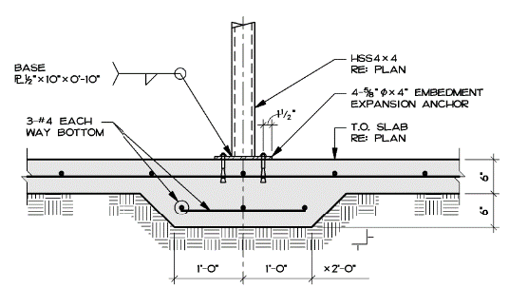
- Detail 2: Details appears to be missing specific information related to embed plate. Provide missing information.
5/8” diameter post-installed anchors with 4” min embed. 3/16” min fillet weld all around HSS at base plate
Sheet S-502
- Provide masonry information including specifications and details
Refer to “Masonry Patching Notes”
- Provide information of existing masonry to be matched for repairs
Matching materials to be selected and approved by COR. Contractor shall provide manufacturer’s standard line of samples for selection by VA.
- Clarify that details which are for catwalk are generic and not product specific. If specific catwalk is to be used provide information.
Catwalk details are generic and not product specific. Contractor may use approved catwalk systems per the specifications.
- Detail 4:
  - Note refers to details 1-10 this sheet. Provide clarification or details
See Bulletin No. 1 dated October 7th, 2021
- Detail 9: Detail calls for field weld to existing catwalk. Has paint been tested for lead content?
It is known the catwalk is less than 10 years old. The contractor may assume there is no lead in the paint.

Sheet MD102
- Coded note 1: Provide detail / photos of existing items to be removed.
Contractor should visit site and become familiar with existing conditions. All components are visible. Any work to remove conveyor equipment must be included in bid price.
COR Response - Picture of the bucket elevator can be obtained at the site visit?

Sheet MD103:
- Coded note 11: locate coded note. Not found
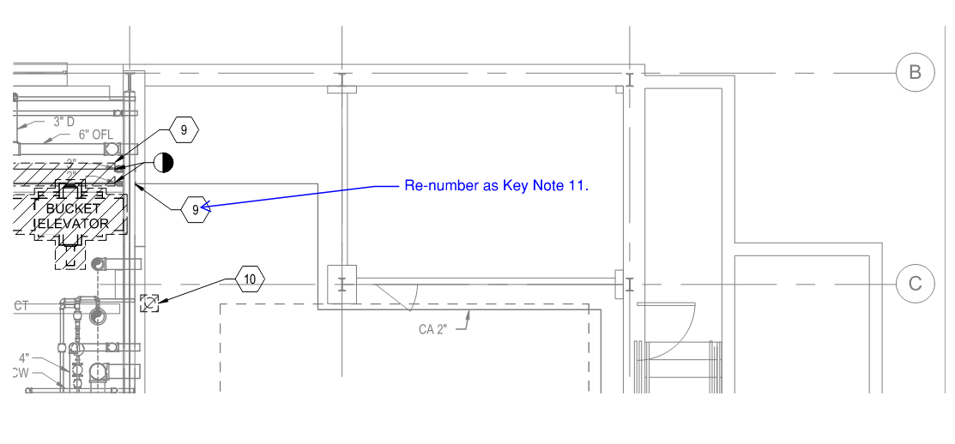
Intent is all compressed air piping in the boiler plant shall be removed, except were shown to remain. MD603 shows a diagram of the piping in the boiler plant.
Sheet MD104
- Coded note 1: Provide opening to be patched including sizes and materials
Refer to structural details for materials. Following image shows approximate size of both chute and MPS/MPR penetrations to be infilled. Pipe penetration is not shown on MD105, however the intent in shown on MD601
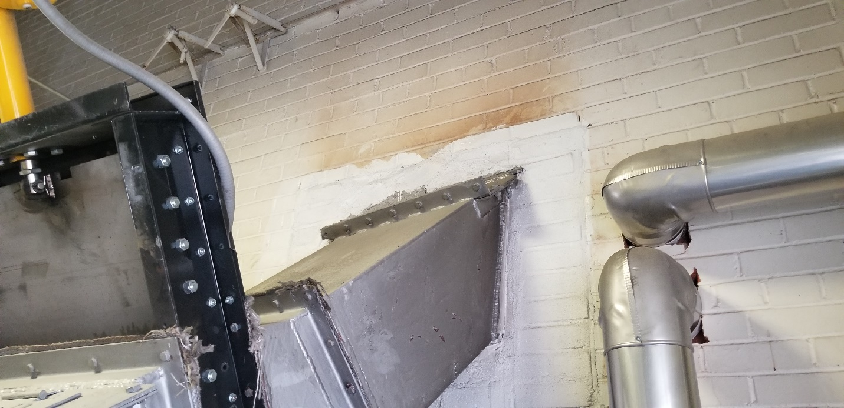
- Coded note 3: Provide opening to be patched including sizes and materials
Refer to structural response.
- Coded note 4: Provide opening to be patched including sizes and materials
Refer to structural details for materials. Following images show approximate size.
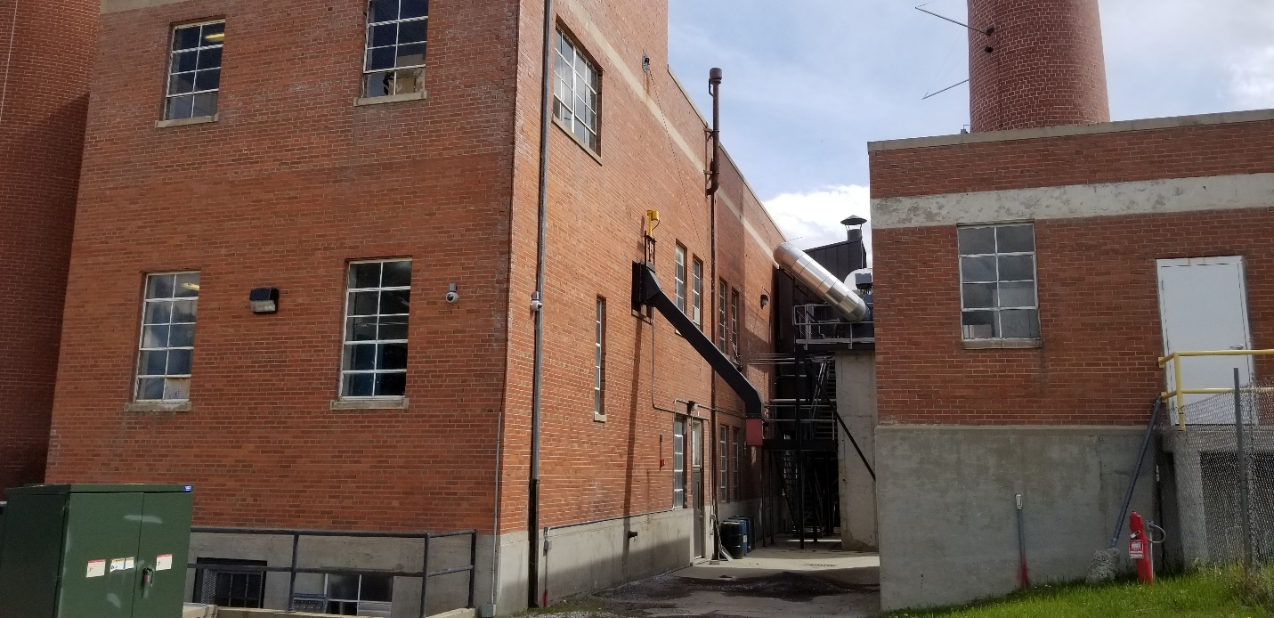

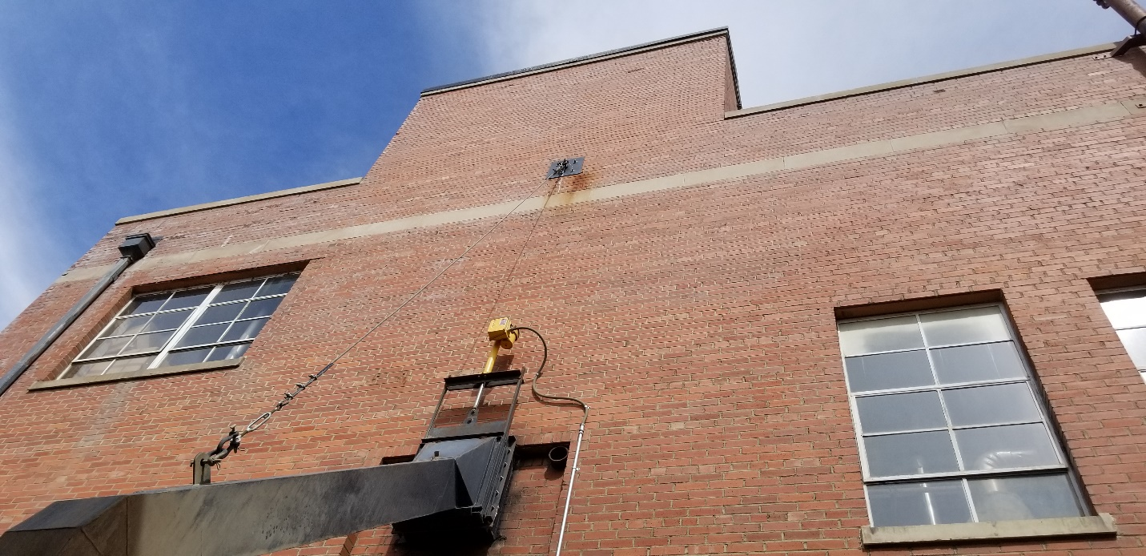
- Coded note 12: Provide opening to be patched including sizes and materials
Refer to structural details for materials. Approximate size is 10’x5’
- Coded note 16: Provide mounting details
Secure to wall with manufacturer recommended wall hanging bracket.
Sheet MP105:
- Coded note 1:
  - Provide roofing information
    - Roof type?
See Detail 2 on sheet S-503
    - Roof under any warranty?
The roof is no longer under warranty.
  - Piping size for openings?
Coordinate with Mechanical drawings
Sheet MP502
- Concrete base called out. Reference question as per sheet SD101.
  - Provide specific details for orientation to existing floor and new concrete pad
Reference Structural responses.
  - Provide 16” pad details including reinforcing
Reference structural responses
Sheet ES101
- Clarify if path as shown on sheet CS 101 for LPA line and electrical per sheet ES 101 can run parallel?
Yes, they can be run in the same trench.
- Provide site light pole specification.
See Spec 26 56 00 2.2
Sheet EL102
- Coded note 1: Provide get the existing model and manufacturer of fixtures.
Should not be necessary as fixtures only being relocated.
- Coded note 2: calls for removal and relocation of existing high bay light fixtures and relamping. Provide photo of existing to be retrofitted / relocated for accurate pricing
See attached photo DSC02962.jpg.
  - Note that reuse of existing fixtures does not carry any warranty and installation of new light fixtures may in fact be more cost effective. Confirm that this is acceptable. If approved provide specifications for new high bay lighting to be used and mounting information
Existing equipment being used will not carry warranty. Existing will be saved and relocated, new fixtures (per lighting schedule) are a different type and will need to be purchased, installed, and warrantied. See sheet EL102
Sheet EJ101
- Project scope is to install on the new smokestacks and reconnect to existing system. Is there an as-built or construction submittal layout for the current Lightning Protection System from the original installer.
See previous drawing of lightning protection. We do not have as-built or construction submittal.
- Specification Section 26 41 00 calls to re-certify the system, which will include all existing portions of the system currently in place, including downleads, and grounding. All parts of the structure will be inspected under a re-certification process and if any of the existing portions of the system are out of compliance with the lightning protection standards, they must be repaired prior to the UL inspection. Additionally, some ground terminals will need to be exposed to verify their condition.
  - Confirm that it is understood that all repairs to the existing system cannot be included within the base bid proposal and will be submitted as an extra prior to repairs and recertification.
Contractor should visit site and become familiar with existing conditions. All components are visible. Re-certification and any work to bring into compliance must be included in bid.
- Confirm if it is the intent of the project is to make sure the entire system is up to current standards. If this is correct the scope of the lightning protection work will not be limited to the new stacks only. If the intent is to ensure that the stacks are correctly hooked into the existing system a limited scope inspection can be performed that covers only the new work performed that will result in a Letter of Finding report.
Yes, intent of the project is to make sure the entire system is up to current standards.
- Is there a current or expired certification on the system, if so who is the inspection authority (ie UL, LPI,) and what is the certification number and date of inspection.
See Spec. 24 41 00 3.2 UL
- Are the existing rooftop lightning protection materials copper or aluminum based or mix of both?
Mix of both.
- Was the larger smokestack on the plan N side part of the lightning protection system for the building or was it separate.
It is part of the overall lightning protection system.
- Are there pictures available of the rooftop in its current condition.
Yes see attachments.
- What type of gasses are going to be coming out of the new smokestacks and at what temperature?
New boilers will be natural gas and products of combustion typical of natural gas combustion.
- Provide clarification on what are the new stack materials (i.e., galvanized, stainless steel, mild steel) and what are the dimensions, wall thickness OD, ID etc., how tall above the roof will they extend, and is there a rain cap/cover on the top.
See Spec and drawings.

Sheet E602
- Coded note 2: Calls for a new breaker to be installed, can we please get the bucket/breaker information needed. Is this a full bucket replacement or are we retrofitting the existing?
The intent was to retrofit existing, however full bucket replacement is acceptable.
- Provide distances on new feeders or schedule a site visit to take measurements.
Distances can be measured during the site visits.

- On drawing MI101, under the master control panel engineering notes, Item 7 specifies “Delete the engineering notes from the project drawings.”, as well as other items marked as “When Specified”….This appears to be a copy & paste from VA master dwg SD230911-04.DWG. Is this an accurate panel and devices required by the project specification?
Engineering notes are not applicable to this project.
Recorders are not required. Provided, as is the case with most systems, that the data which has traditionally been recorded on a "circle chart" is logged via a computer-based logging system (typically referred to as SCADA, although the VA does not allow any "C" (control) via the remote logging system.)
This is a typical panel. Other panel designs that still meet the requirements in 23 09 11 are allowable.
- Drawing MD604 indicates that Condensate Pump Controller, Surge Tank Controller, Deaerator Controller, and Boiler 3 PLC are not to be demo’ed. However, on drawing MD103, the Hays Cleveland Boiler control panel & Fireye burner control panel for Boiler #3 are to be demo’ed, as well as the complete Hays Cleveland Master Control Panel. Since the Condensate pumps, Surge Tank Level, and DA tank level control reside in the Hays Cleveland Master Panel, are those controls to be saved and relocated, or provide new?
Boiler 3 control panel and Fireeye burner control panel shall be demolished.
Condensate pump, surge tank level, DA tank level controls can either be migrated to the new panel or be provided as new. The intent is for the new system to operate as one cohesive system and the contractor shall ensure the end product is a fully integrated system.
- Drawing MI101 Master control panel layout shows recorders in the master panel, however Specification 23 09 11, pg 59, pp 2.12 “Recorders” is listed as “Not Used” please advise which is correct.
Recorders are not required at the master control panel. Provided, as is the case with most systems, that the data which has traditionally been recorded on a "circle chart" is logged via a computer-based logging system (typically referred to as SCADA, although the VA does not allow any "C" (control) via the remote logging system.)
- Drawing MI101 Master control Panel layout shows item 14, Smoke Density Monitor (When Specified), and specification 23 09 11, pg 58, pp 2.8 “Boiler Stack Opacity Monitors” lists the devices as “Not required”. Since the opacity monitors and recorders are not required, will the control panel still be required to be 12’ wide?
Devices are not required. Panel width should be understood as typical or worst case.
- If the Master control panel is still required to be 12’ wide and not have all the recorders and opacity monitors installed, can the boiler combustion controls be located in the master panel in place of at each boiler?
Panel width should be understood as typical or worst case. Boiler combustion controls must be located at the boiler.
- Drawing MI101 Master control panel layout indicates a light hood to be supplied, but it is not specified in 23 09 11 pg 30, pp 2.3.B Panel Construction. Is the Light hood required?
Not required or prohibited.
- Specification 23 09 11, pg 30, pp 2.3.B.4 indicates that rear doors on the master panel are required. However, drawing MP103 has the location of the master panel against the south wall of the plant making rear doors inaccessible. Please state if front doors with instruments mounted in the doors, is acceptable.
Front doors are acceptable.
- Drawing MP604 indicates main gas regulator feeding the plant is set for 30psig, while drawing MP601 natural gas flow meter schedule lists gas company base pressure of 45 psig. This will affect sizing and max flow calculation of meter.
30 PSIG is the nominal pressure at the meter. MP604 is correct.
- No plant gas flow meter is shown on drawing MP604 for LPA header. Will one be required as there is one on the natural gas header?
Flow meter is not required for the LPA header. This information will be based on the fill logs from the Propane Gas supplier.
- Will vaporizer air mixer skid be set to provide LPA at same pressure, specific gravity, BTU content and density as natural gas, or should a second gas flow meter and PRV be required for LPA to each boiler?
The LPA shall be mixed to be a synthetic natural gas. Redundant flow meter and PRV is not required per basis of design. Ensure provided PRV can accommodate both 10 PSIG synthetic and 30 PSIG natural gas. For the Flow meter, manufacturer shall provide correction factor for the 10 PSIG Synthetic gas. When the manual change over at the boiler is conducted, the controls for the flow meter shall meter for the synthetic gas.
- Drawings MP602 only shows a single feedwater header feeding the boilers from the feedwater pump set. Typical VA arrangement is to have two headers, so one can be worked without shutting down the plant. Is only one header required for this plant?
Contract documents do not require redundant feedwater header.
- Drawing MP603 shows existing steam flow meters M-1 thru M-4. Existing meters are currently pressure compensated in existing Master control panel, but Pressure transmitters are not show on Drawing MP603. Will flow readings need to be pressure compensated and will existing pressure transmitters remain to be re-used?
Flow readings need to be pressure compensated and the existing pressure transmitters shall remain to be re-used.
- Existing steam header vent valve is automatically controlled thru master control panel but drawing.
Valve shall also be manually operated type.
- Please advise who is responsible for filling tanks PT-1 and PT-2.
Contractor shall fill PT-1 and PT-2 for testing and provide full tanks prior to project turn over.
- Please confirm the contractor is responsible for a delegated pipe support system design as outlined in 23 21 11 1.4-11 & 2.29.
Yes
- Will the Government sign a sales tax-exempt certificate?
In Wyoming where the purchaser takes receipt of goods/series dictates the jurisdiction where sales tax is assessed. Currently when materials are delivered to a federal installation, to include veterans’ hospitals, the Department exempts them from Wyoming sales tax under W.S. 39-15-105(a)(i)(A). [W.S. 39-15-104(f)(i)]”
As the Cheyenne VA Medical Center is a federal installation, the receipt of materials by a contractor at these federal installations would be exempt from sales tax.
- Please confirm the VA is hiring the Commissioning Agent per 01 91 00 1.8-C.
See Section 01 91 00 – 15 / Paragraphs 1.8 (Commissioning Team), 1.9 (VA’s Commissioning Responsibilities) and 1.10 (Contractor’s Commissioning Responsibilities)
- Please confirm the Project Superintendent can fulfill the role as SSHO per 013526 1.7-C. Confirm this role doesn’t have to be a separate individual.
See Section 01 35 26-11 / Paragraph 1.7 “Site Safety and Health Officer” and “Competent Person”
- Please confirm the Project Superintendent can fulfill the role of Quality Control Manager per 014500 1.4-B.
Answered by # 34
- File Size Limit: Please clarify if the file size limit is 15 MB (as mentioned on solicitation page 12) or 5 MB (as mentioned on solicitation page 14).
File size limit is 15MB.

- Please confirm the aboveground propane tanks shall be insulated with calcium silicate with glass cloth or aluminum jacket, weatherproof jacket per 23 07 11 3.6.
Insulation of the above ground propane tanks is not required.
- Does the Government want the Contractor to re-insulate the deaerator feedwater heater, tanks per 230711 3.5?
Reinsulate as required to perform work or if damaged during contractor work. Otherwise, existing insulation can remain.
- Reference Phasing Note 8.2, M-001, it states that the contractor shall provide maintenance on existing equipment. Please confirm the Government will continue to maintain and operate the existing equipment and no preventative maintenance is required by the Contractor on the existing equipment to remain.
The intent of “maintenance” in this note is the specifically noted improvements of existing equipment, either in specifications or drawings. Preventative maintenance will be conducted by the government on all existing equipment.
- MI103 has various notes indicating “allow for integration into BAS”. Specification section 230923 was not provided. 230911 is not BAS. Does the Government want the Contractor to contract with the proprietary BAS contractor for integration with the Boiler Plant controls? Who is the proprietary BAS contractor on campus?
That is the intent. The control system shall connect to the Building Automation System using BACNet or LONWORKS protocol for monitoring and management. This will require connection and communication with the Trane control system in building 90 which will be BACNet soon.
- 23 21 11 2.24 outlines Emergency Gas Safety Shut-Off Valve(s). This valve is not outlined on MP604. Please confirm this valve is not required.
Emergency Gas Safety Shut-Off Valves are shown on MP601, MP604, and MI103. Valves are required.
- Please provide make/model of existing condensate return pumps. It appears they are an integral package to the condensate tanks.
Packaged pumps are Sterlco, Sterling Steam Control Products Model 0422536-JDAX
- 23 50 11 2.2 Feedwater Deaerator with Storage Tank and Accessories is included in the project specifications, however the storage tank is to remain. Please advise if the Government’s intent is to get a new deaerator.
A new deaerator is not in the contract documents. The intent of 2.2 is to specify the replaced spray head and steam safety valve and any interconnecting piping required to be replaced as required to perform the work on the feedwater deaerator with storage tank.
- Please provide the following information for Superior Boiler #3 – 25,000 lb/hr:
  - Nameplate picture
  - Burner nameplate picture
  - Safety Relief Valve setting

  - Existing level controller
  - Existing feedwater valve (open/close vs modulating)
  - Pressure Vessel MAWP if not on the nameplate
  - Any dimensional or factory provided documentation (Specifically furnace dimensions for burner conversion configuration. Mounting ring dimensions, furnace pressure, shape and depth.)"
See pic IMG_0217.jpg
- Please provide the following information for Existing Surge Tank:
  - Tank Nameplate
  - Vessel Gallonage – or Vessel Diameter and Length
  - Any dimensional or factory provided documentation (dimensional, P&IDs, Wiring diagrams)
  - Pressure Vessel MAWP if not on the nameplate – or stated if atmospheric
  - Pump nameplates and motor hp if available
  - Tank stand height
  - Unit photos showing level controls if dimensional information is not available"
See pic IMG_0219.jpg

- Please provide the following information for Existing Deaerator Tank:
  - Tank Nameplate
  - Vessel Gallonage – or Vessel Diameter and Length
  - Any dimensional or factory provided documentation (dimensional, P&IDs, Wiring diagrams)
  - Pressure Vessel MAWP if not on the nameplate
  - Pump nameplates and motor hp if available
  - Tank stand height
  - Unit photos showing level controls if dimensional information is not available"
See pic IMG_0218.jpg

- MP101 does not depict compressed air piping out to the skids/tanks for the pneumatic controls. Shall all control valves be electrically actuated. Please advise.
The basis of design was all electrically actuated. No compressed air required at the propane tanks.
- Please provide a geotechnical report/boring reports for the propane tank location.
See attached report.
- Is 3 element feedwater control required?
Refer to Specification Section 23 09 11 Para. 2.1.K.6, single element feedwater control.
- Are the auto recirc valves required?
Yes.
- Who is responsible for testing the boilers for radiation?
  - What is the process for abatement if radiation is detected?
The contractor will be responsible for testing and if radiation is found then abatement procedures will be completed.
- What are the current government guidelines for vaccinations versus weekly testing of employees?
  - If weekly testing is allowed, who bears the expense for the testing, and/or what is the cost if it is the offeror’s responsibility to pay for them?
  - Are these requirements going to come out in an addendum, or are they in the contract documents already?
COR Question / COR Response – Presidential EO 14042 September 09, 2021 lists the requirements. It is the cost of the offeror and should be determined through their own resources.
- Who is responsible for the temporary boilers that are currently in place?
  - Will this contract include removal/decommissioning of the temporary boiler after the new boilers are installed?

Government will continue to conduct preventative maintenance. Contractor shall coordinate with VA COR for startup and shut down as required in the phasing plan. Removal is not required in contract documents.
- When does the 270-day project timeline start? We are waiting to hear back on the lead times for the boilers. This could impact construction schedules.
See question 8 on page 2.

- Specification Section 09 05 16 Subsurface Preparation for Floor Finishes has been included with the solicitation documents, specifying floor prep for “applied and resinous flooring”. No specification was included for Resinous Flooring, No Finish Schedule or plan location was provided for any floor finishes.
  - Please confirm, no new floor finishes are required in the solicitation.
Specification applies to floor finishes in areas that are patched, replaced, or otherwise repaired due to the work. Such areas shall be finished to match adjacent floor finish.
- Specification Section 09 29 00 Gypsum Board has been included with the solicitation documents. No Architectural Drawings or Framing Specifications were provided with the construction documents.
  - Please confirm, no framing or drywall are required in the solicitation.
See response to item 13, above.
- Specification Section 09 91 00 Painting, paragraph 1.1A indicates “Work of this Section includes all labor, materials, equipment, and services necessary to complete the painting and finishing as shown on the construction documents and/or specified herein, including, but not limited to, the following:”. No architectural plans were provided with the contract documents, No Finish Schedule was provided with contract documents, Specification Section 09 06 00 Schedule for Finishes was not provided with the contract documents.
  - Please provide Architectural Plans, Finish Schedule, and Specification Section 09 06 00 that specify/detail any required painting.
Specification applies to paint finishes in areas that are patched, replaced, or otherwise repaired due to the work. Such areas shall be painted to match adjacent finish.

- During the Site Visit, the VA representative referenced construction phasing. No Phasing Plan was provided in the Contract Drawings or detailed in the Statement of Work.
  - Please provide plans and a SOW for any required construction phasing.
Phasing plan is denoted on M-001 and phasing requirements are referenced in the mechanical plans.
- During the Site Visit a Temporary Boiler Trailer was noticed on the south side of the building. This boiler is not shown on the contract drawings.
  - Please provide drawings depicting the piping, power, and control wiring connection to the boiler plant systems. Drawings do not exist.
  - Please confirm this boiler is controlled from a Local Boiler Control Panel and not connected to the Master Boiler Control Panel. It is, with a separate alarm panel in the control room.
  - Please confirm the VA will retain responsibility for the rental cost, repair, and maintenance of the temporary boiler.
VA will.
- During the Site Visit it was noted that the existing coal boilers had been in service for (4) four years.
  - Please provide a current test report confirming the existing boilers do not contain any radioactive wastes.
Yes, see attached boring report issued 2/5/19. The propane tank location will correspond to borehole #3.
- What COVID restrictions will be in place during this project?
  - Will vaccination of all employees be required?

  - Will masks be required?
  - Will weekly testing be required for employees that are unvaccinated?
See Clause 52.223-99 Ensuring Adequate COVID-19 Safety Protocols for Federal Contractors below.
- The Period of Performance specified on the Solicitation is 270 CD’s. The boiler submittal, design, manufacture, and delivery process could take up to 6 months under the current procurement conditions.
  - Please confirm an Administrative NTP will be issued for equipment procurement.
See question #8 on pg. 2
- During the Site Visit, compression EMT connectors and couplings were observed throughout the facility. Set screw type couplings are not specifically disallowed in the specification.
  - Will set screw type EMT connectors and couplings be permitted?
No, follow VA specifications
- During the Site Visit, liquid tight conduit was observed throughout the facility. However, flexible metal conduit is allowed in the specifications.
  - Will flexible metal conduit be allowed?
Specification allows flexible metal conduit in some locations and liquid-tite in others. Most locations will allow flexible MC per specs.
Use flexible metal conduit for connections to motors and other elec equipment subject to movement, misalignment, cramped quarters, or noise transmission.
Use liquid tite flexible metal conduit for installation in exterior locations, moisture or humidity laden atmosphere, water or spray wash operations, inside airstream of HVAC units, and locations subject to seepage or dripping oil, grease or water.
Provide a green equipment grounding conductor with flexible and liquid tite flexible metal conduit.

- During the Site Visit it was observed that all condulets, fittings and boxes inside the building appear to be intended for wet locations.
  - Is the interior of the building considered a wet location?
No
  - If so what will the NEMA standard for junction boxes be?
Interior is not a wet location.
  - Will standard 4 square device boxes and covers be acceptable anywhere inside the facility?
Yes
- During the Site Visit it was observed that the existing exposed conduit are not painted.
  - Will exposed conduits be required to be painted as specified in 26 05 33 3.4 G
Yes, follow specs.
- Referring to the Lightning protection on sheet EJ101 and spec section 26 41 00.
  - Is keynote #1 on sheet EJ101 the only location that new lightning protection is required?
Yes
  - Is the contractor expected to re-certify the entire system?
Certify the new up to the point of connection to existing.
  - If so, will access be provided to the top of the existing smoke stack?

Coordinate with COR.
  - If deficiencies are found in the lightning protection system during re-certification, will that be addressed as a change order?
The original lightning protection was certified so no changes are anticipated. However, if this is an issue it can be brought to the attention of the COR. There may be other options.
- Will a temporary boiler be required while boilers 1 and 2 are down?
  - Can both boilers 1 and 2 be demoed simultaneously?
Boilers can be demoed simultaneously. Ensure plant remains functional on boiler 3 and the existing temporary boiler
- Refer to Dwg MI101, Engineering Note #3 "Some recording and monitoring functions........".
  - Is it acceptable to have all (rather than some) recording and monitoring functions performed by the workstation rather than the chart recorders and other devices?
Recording functions are not required at the main control panel.
- Refer to Dwg MI102 Sequence of Control Note E, Describes a PLC for boiler control. Spec 230911-16 requires UL and FM approval and UL approval per UL 1998. PLCs do not have FM approval-- only UL approval.
  - Would a PLC such as Allen Bradley Compact Logix, that is UL approved be acceptable for the boiler control PLC?
PLC with UL approval is allowable. The UL approval of the PLC Hardware alone is inadequate. The control Logic (software) must be factory-only accessible, and UL1998 Listed as well.
- Refer to Dwg MI102 Sequence of Control Note E "..... and integrated into the PLC provided by the boiler manufacturer."
  - Is it acceptable for a controls contractor that specializes in burner management and boiler controls, with a minimum of 10 years’ experience and customer references, to provide the burner management and boiler controls.
Both can be provided by the same manufacturer, but the VA requires each device to be independent. The contractor will need to meet the requirements of both burner and boiler. There are two Burner Management/Safety Controls typically seen in the VA (current manufacture)- The Fireye YB110 series (which the Sheridan Staff are familiar with- it is present on Boiler 3) and the Honeywell 7800 series (which is a very similar unit, in operation if not configuration.) Absolutely NO "both in one device" Safety and Combustion Control systems.
- Refer to Spec 230911-16 and 230911-12 electric drives.
  - Does the VA prefer nonproprietary controls and actuators?. For example-- the actuators and control components should use standard 4-20 madc control signals versus proprietary bus communications, CANBUS, or other protocols.
Either is allowed if it meets the specifications. The VA has accepted Cleaver Brooks CB Hawk systems (which utilize modbus) and Hays Cleveland systems (which utilize mA current loops.)
- Refer to Spec 230911-16. 2.a "Software shall be factory programmed by the controller manufacturer only" This statement would prevent programming by qualified burner/boiler controls companies and also prevent the use of PLCs as described in Dwg MI101. It would also prevent the use of any PLC, Fireye, Honeywell, or Cleaver Brooks system.
  - Is it acceptable to be programmed by a qualified burner/boiler controls company?
The VA does not accept "field-alterable" programming logic for a Combustion Control System, or for a Burner Safety Control System. UL1998 Listing of the Control Software is required. The VA interpretation (as well as most- if not all- controls manufacturers') of that means that no alterations of the basic logic can be undertaken once the software is installed in the controller. What is allowed (in fact, required) is the capability to enter and edit fuel-air curves for various fuels, "in the field". In other words, you can change the set-points, but not how the controller uses those set-points.
Burner/boiler control shall be by PLC, Fireye, Honeywell, or Cleaver Brooks system. Each of those companies shall program the imbedded logic. Hays Cleveland and Trane shall program their respective portion of the controls as indicated in the specifications.
- Refer to Drawing C-001, General Note #1 “ References within this drawing set to Phase 3….”
  - Please provide the Phase 3, Project 666-16-117, Contract Drawings.
  - Please provide any “VHA COR Additional Project Requirements.”
  - Will the “Phase 3” work be completed prior to the start of this project?
There will be no phase 3 work conducted.

- Refer to Drawing S-101, KN #3 indicates to “ Infill Exterior Trench…”
  - Please provide the depth of this trench.
Please see answer to 1-coded note 3.
- Please confirm the number of employees required on site at all times (as employed by the offeror)
Working method of the contractor shall be at the discretion of the GC. At a minimum an appointed supervisor must be onsite while project work is taking place. Supervisor must have OSHA 30 training.
- Refer to Specification Section 01 35 26, 1.7 Site Safety and Health Officer (SSHO).
  - Can the Site Superintendent also perform the duties of the SSHO and the QC Manager?
See section 01 35 26 – 11 / Paragraph 1.7 (Site Safety and Health Officer / Competent Person) Items A-E
- Please confirm the SSHO must be an employee of the Offeror.
It shall be the GC appointed person with the required qualifications.
- Please confirm the CQC System Manager must be an employee of the Offeror.
It can be, or a qualified sub-contractor appointed by the GC.
- Refer to Drawing SD101 KN #2 “Patch and repair existing concrete pads”
  - Please confirm the noted “16” Think Concrete Pad For Boilers” are to remain.
16” thick concrete pad for boilers to remain
- Refer to Sheet S-001, Soils Note #1 references a “Geotechnical Engineer of Record.
  - Please provide a copy of the Geotechnical Engineer of Record’s soils report.
Refer to attached report
- What is the gross weight of the existing boilers to be removed?
Approximately 30,000 lbs.
- Refer to Amendment #3, Question #1 “Does the north (2) two panel sections need removed in the MCC? Detail 1/E502 does not depict this work or any required “future wall construction”. The response requires design work to “Provide an approved manufacturers solution…” that is not part of this solicitation.
  - Please provide updated plans that detail any required modifications to the MCC.

Removal of the two North end sections of the MCC will be part of the project. There are no plans or details of the removal. A manufacturer approved method of removal will be the responsibility of the successful offeror.
- Refer to Amendment #3, Question #2 “Are Crosby (adjustable) style steam pressure safeties required?” The response is “Yes”.
  - Please provide the location and quantities of these “Crosby (adjustable) style steam pressure safeties”.
Refer to MP601 VA required Safety Devices, PSD-1.
- Refer to Amendment #3, Question #3 “Do the boiler stack economizers need pressure and temperature gauges on the inlet and outlet water connected to the control system?” These are not shown/specified on the contract documents.
  - Please provide a specification for the desired pressure and temperature gauges

  - If these devices are to monitored/controlled, please provide an updated Points Lists and One Line Drawing MI102 & MI103.
Requirements are identified in 23 09 11.
- Refer to Amendment #3, Question #5 “Does the VA require the large size control house option on the propane air mixing station?” The response was “Yes”. A “Control House” is not specified on the Contract Documents.
  - Please provide a specification for the “large size control house” and provide drawings depicting the location and any foundation requirements.
Control house is shown on Detail 2/ MP503. Size on the site plan is integral with skid shown on the mechanical site plan MP101. Basis of design size: 48" x 48" x 90" (D x W x H). Control House shall be constructed to meet IBC 2021 requirements, weatherproof and contains an LED light fixture to light floor at 30-foot candles, a NEMA 5-20R 20A Outlet and furnished to house the associated controls to operate the mixer and vaporizer. It shall be integral to air mixer and provided on the same skid as the air mixer. All components to the air mixer and vaporizer shall be submitted in one submittal.
- Refer to Specification Section 01 45 35 Special Inspections, paragraph 1.1 indicates the Designer of Record (DOR) will perform the Special Inspections.
See section 01 45 35 “Special Inspections” / Part 1, Part 2 (1.1-3.2)
- Please confirm the VA or the DOR will perform any required Special Inspections.
See section 01 45 35 “Special Inspections” / Part 1, Part 2 (1.1-3.2)

- On sheet MI101, Master Plant Control Points schedule, what does CC indicate? Answer – CC indicates items furnished and/or installed by the Section 23 09 11 contractor.

- How will Trane parallel the plant signals? Answer – The 23 09 11 Contractor will provide a communication bridge with a BACnet protocol for the Site System Integrator “DDC” contractor (Trane) to use for trending, logging, and display of items listed on MI101 and MI102 under “DDC”.

- Will the control of all boiler plant functions be capable from the control room? Answer – Everything listed in specification 23 09 11, except the startup of the boilers and burner management (flame safety Control), will be possible from the control room. Refer to the full Specification 23 09 11 and specifically Paragraphs 2.1.A.4.c, 2.1.D.2.f and 2.5.

- Will the proprietary Hays Cleveland combined touch screen/computer units in the master and sub control panels be replaced. Answer – Yes. The intent is for the control computers to be stand-alone units mounted in the cabinets with remote touch screen monitors connected by cable and mounted on the face of the panels per specification 23 09 11.

FAR Deviation Clause
Executive Order 14042, Ensuring Adequate COVID Safety Protocols for Federal Contractors September 30, 2021
PART 52—SOLICITATION PROVISIONS AND CONTRACT CLAUSES
*****
Subpart 52.2—Text of Provisions and Clauses
*****
[52.223-99 Ensuring Adequate COVID-19 Safety Protocols for Federal Contractors.
ENSURING ADEQUATE COVID-19 SAFETY PROTOCOLS FOR FEDERAL
CONTRACTORS (OCT 2021) (DEVIATION)

(a) Definition. As used in this clause -
United States or its outlying areas means—
- The fifty States;
- The District of Columbia;
- The commonwealths of Puerto Rico and the Northern Mariana Islands;
(4) The territories of American Samoa, Guam, and the United States Virgin
Islands; and
(5) The minor outlying islands of Baker Island, Howland Island, Jarvis Island,
Johnston Atoll, Kingman Reef, Midway Islands, Navassa Island, Palmyra Atoll, and
Wake Atoll.
(b) Authority. This clause implements Executive Order 14042, Ensuring
Adequate COVID Safety Protocols for Federal Contractors, dated September 9, 2021
(published in the Federal Register on September 14, 2021, 86 FR 50985).
(c) Compliance. The Contractor shall comply with all guidance, including
guidance conveyed through Frequently Asked Questions, as amended during the
performance of this contract, for contractor workplace locations published by the
Safer Federal Workforce Task Force (Task Force Guidance) at
https:/www.saferfederalworkforce.gov/contractors/.

(d) Subcontracts. The Contractor shall include the substance of this clause,
including this paragraph (d), in subcontracts at any tier that exceed the simplified
acquisition threshold, as defined in Federal Acquisition Regulation 2.101 on the
date of subcontract award, and are for services, including construction, performed
in whole or in part within the United States or its outlying areas.

(End of clause)]

