- Could you tell us whether the solicitation package states an estimated magnitude of construction or cost range, and whether a bid guarantee/bond is required with the offer? See page 1 of solicitation for estimated magnitude of construction. See Contracting Officers instructions and related clauses for Bid Guarantee and Bonding Requirements.

- Will Hunter Douglas be accepted as a manufacturer for window shades?
All manufacturers/products are acceptable if they meet the specifications.
The documents indicate that Items 203, 204B, and 205B are to be furnished and installed by FSEC, while Items 204A and 205A are to be furnished and installed by the Owner. Can you please confirm who is responsible for providing, furnishing, and installing each of these items? I would like to ensure that the scope of responsibility is correctly understood.
Items noted above are to be furnished and installed by the FSEC. Documents will be corrected to read as such.

- Plan Sheet EE001 - Please identify the electrical requirements and feeders for equipment tag DWP-1-01 and SWH1-01? I am unable to find any information provided with the plans.

Omit DWP and SWH. Reference addendum 01_2026-10-09.

- Plan sheet EP101 - In kitchen area 143 please identify what these symbols represent or are doing. 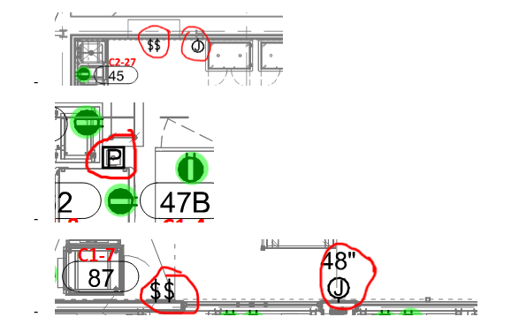
Omit junction box and switches from plans. Addendum 01_2026-10-09 will remove devices from plans. P device is a power pole to allow equipment to get powered.

- Plans sheet EP101 - In retail area 188 there is a j-box denoted can you please provide further information for what this is for?
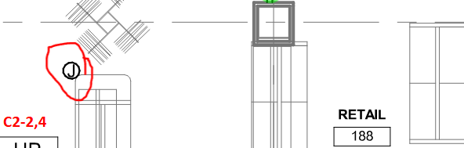

Omit, Reference addendum 01_2026-10-09

- Plan Sheet EL201 - Please confirm every fixture on the plan sheet requires a 9234 relay per keynote note #1?

Only Life safety lighting needs 924 relay.

- Per spec section 260533 allow the use of set screw connectors,
Per spec section 270533 allows the use of set screw for fitting great than 2” all other must of compression fittings
Per spec section 280528.33 allows the use of set screw for fitting greater than 2” all other must be compression fittings Would it be acceptable for the use the set screw fittings and connectors for all sizes of EMT and only follow spec section 260533?

Install fittings per specifications

- Plan Sheet EY101 please confirm the following:
  - Sound, security, CCTV cabling will be furnished and free air installation will be don by others. Conduit and back boxes stubbed to accessible ceiling in the responsibility of Division 26
  - Furnishing and installation of the fire alarm complete system is in the SOW of Electrical. Install method Red ¾” min conduit?
Yes to both parts.
- Plans sheet EE300 - Please identify the location on EM DP-EP on the plans.

Location is in room E09
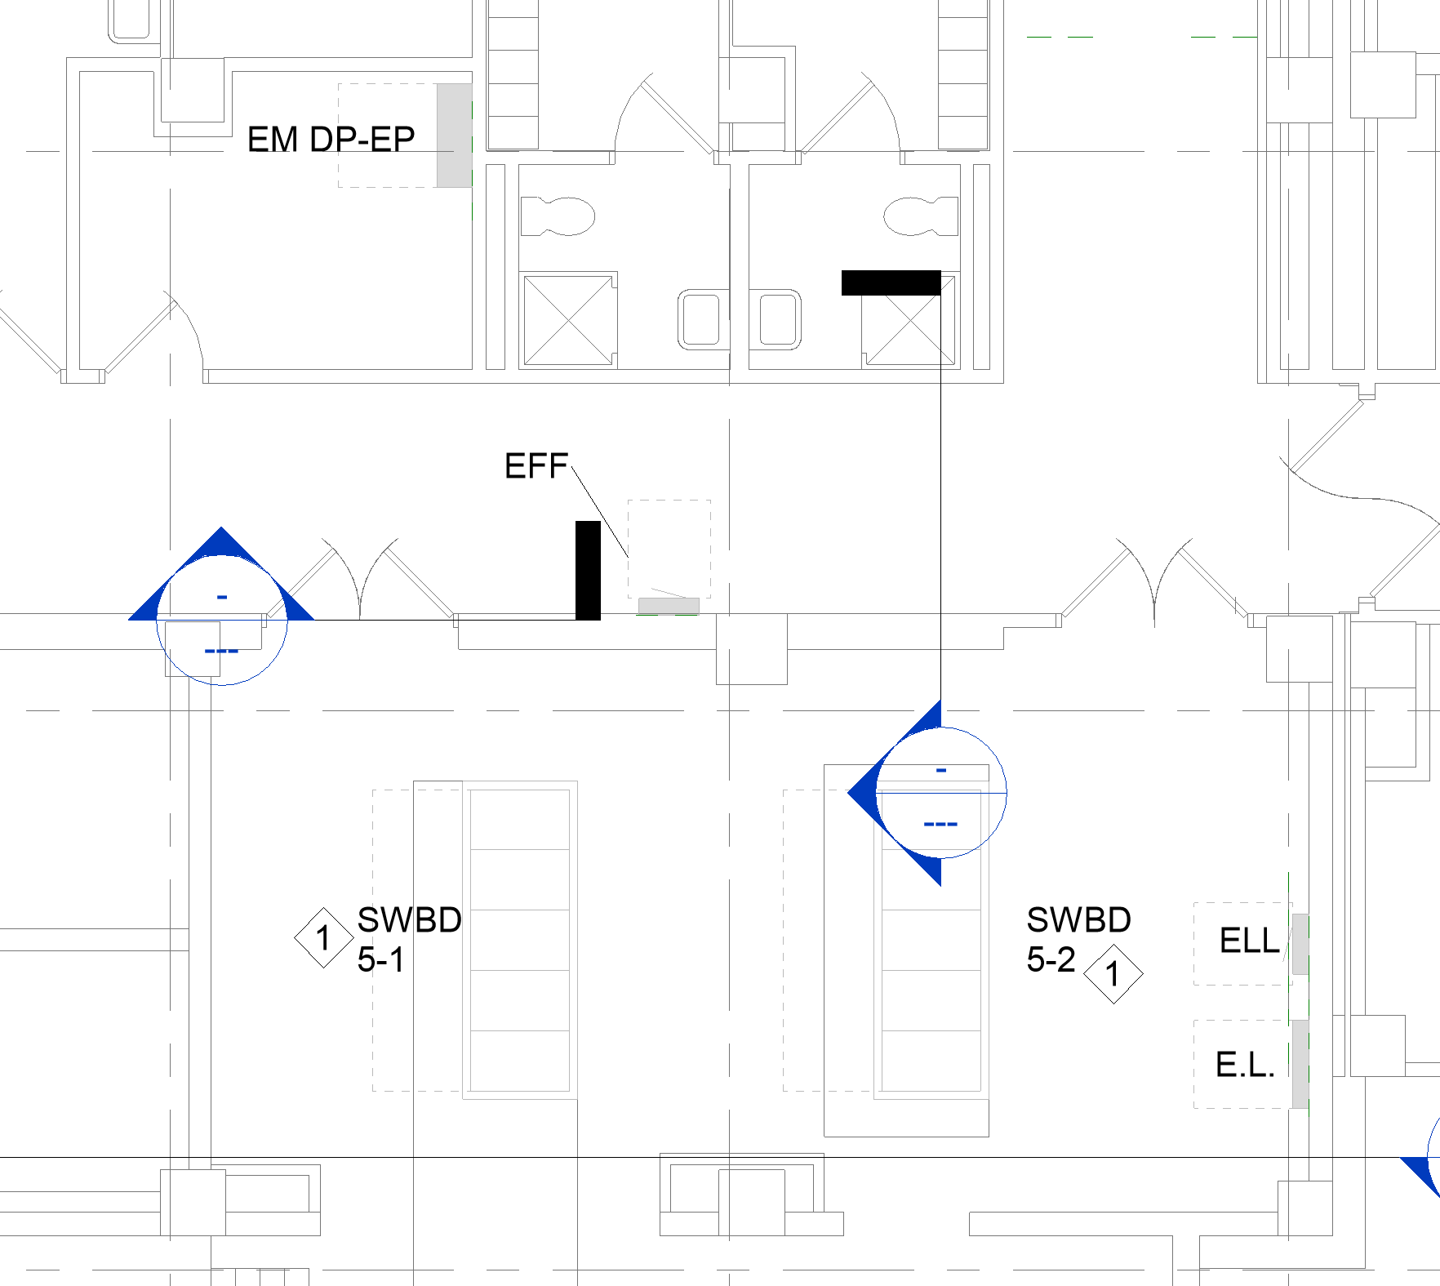

- Spec section 260533 - Please confirm if the use of hospital grade mc is a acceptable approved installation method?

Acceptable, if meets requirements in specification sections

- Will the cubicles and equipment be removed prior to work commencing, or will those items be responsibility of Prime Contractor?
Equipment to be removed by the VA as noted in the drawings. If not noted in the drawings, then it will be removed by the contractor. Twenty-four cubicles will remain to be removed by contractor.
- Section 01 00 00 1.5 – Security Requirements - Can you provide the specific requirements for Badging and Security for this project?
There are three forms that need to be submitted for each construction employee including subcontractors. The process takes an average of two -three weeks per person if the forms are filled out honestly and correctly. The three forms are attached. Notice subcontractors working less than 30 days do not need to be badged. PM and superintendent and all leads from subcontractors to get badged first. The rest of crew can get badged after construction starts as they are needed.
- Section 01 00 00 1.5 – Security Requirements - Can you identify the amount of time required for badging?
See answer to question #12.
- Section 01 00 00 1.5 – Security Requirements - Does the Period of Performance account for employee badging time frame?
Yes. The period of performance accounts for the badging process.
- Section 01 00 00 1.6 – Operation and Storage Areas – Can you provide the location for the contractor staging area?
Operation and storage areas are shown on the phasing plan. Plan sheet G-005-G-009.
- Section 01 00 00 1.17 – Temporary Toilets – Are we able to utilize existing facility toilets for our use during the construction duration?
VA toilets can be used. There are two restrooms in the renovated space that can be used until they are demolished
- Section 01 00 00 1.22 – C.1 Government-Furnished Property – Indicates the VA will provide the storage location that will be provided by Government, but the scope of wok indicates contractor to supply temperature-controlled storage unit. Can you clarify who is responsible for storage?
The general contractor is responsible for the conditioned storage space. The conditioned storage space is planned in front of the west dock overhead door. The VA will provide a source of power for the contractor to connect to for the storage space.
- Section 01 00 00 1.22 – C.1 Government-Furnished Property – Can you provide the shop drawings and product data for the owner provided equipment for coordination and review of assembly and connection requirements?
The owner furnished products/equipment is provided on plan sheet AI100, FS101, and FS103. Contractor provided Submittal Exchange will be used for owner provided equipment review and connection requirements for installation.
- Section 01 00 00 1.24 – Photographic Documentation - Can the superintendent provide the construction progress photos in lieu of a Commercial Photographer?
Photographic Documentation will be per the specifications.

- Section 01 33 23 – Shop Drawings – The scope of work indicates Submittal Exchange, Will Procore be acceptable for (FTP) file sharing, for submittals, RFI’s, transmittals, etc.?
Procore is acceptable in leu of Submittal Exchange. The contractor must use AI100, FS101, and FS103 to ensure all equipment and products are included in the file share system for coordination purposes.
- Section 01 33 23 – Shop Drawings - Can you clarify the review period of Rfi’s and Submittals from the owner includes the review of Architectural and Engineering Services?
RFI time duration is as the following: for critical (cost and schedule delays) 3 days, for urgent, 8 days (schedule delays) and for normal, 14 days.
- Section 01 35 26-Safety Requirements - Can the Superintendent provide a Dual role and perform the Health and Safety Officer role also?

No. Superintendent and SSHO officer must be two different people.

- Section 01 35 26-Safety Requirements - Does the SSHO need to be directly employed by the prime contractor?
SSHO is to be provided by the contractor. The specifications do not dictate what work is self-performed or subcontracted.
- Section 01 45 00 Quality Control - Can the Superintendent provide a Dual role and perform the QC manager role also?
No. Superintendent and the QC manager must be two different people.
- Section 01 45 00 Quality Control - Does the CQC Manger have to be a direct employee of the Prime Contractor?

QC Manager is to be provided by the contractor. See specification 01 45 00.

- Can the Superintendent provide a Triple role and perform the QC Manager and the Health and Safety Officer role also?
No. The superintendent must not have the same role as QC manager and the SSHO. There must be three people filling each role. See items 23 and 25 above.
- Section 01 45 00 – Testing - 3.7 Architectural Precast, can you clarify if this scope of work requires precast materials?
There is no architectural precast concrete in the current scope of work.

- Section 01 91 00 1.8 Commissioning Team - Can you confirm the Commissioning agent is excluded from the contractor’s scope and will be appointed and paid for by the VA?
Commissioning specifications are included in the specifications for the contractor provided quality control manager. Any other commissioning will be by the VA by a 3rd party.

- Section 01 91 00 - Will any of the commissioning for this project require commissioning services for existing systems in the building?
There would only be minimal commissioning of existing systems (mainly to confirm capacity and balancing of areas outside of construction boundaries). Most MEP systems serving this project are defined as new and should be able to be tested separately from existing building’s infrastructure.
- Section 02 82 13 Abatement – Can you provide the asbestos, mold and lead testing analysis report for the items required to be removed?
Hazardous Material Report attached.
- Has a geotechnical report including borings conducted on the areas to be worked on in this scope?
A geotechnical investigation/report was not provided.
- Are there any contaminated soils present in the working area?
We are not aware of any contaminated soils.
- Will any of the work areas on this project require escorts for access?
Badged contractors will be required to escort unbadged contractors until all badging is complete. Escorts will be required for work in the warehouse

- Section 08 11 13 Doors – Can you provide the doors that require blast loading requirements?
Blast resistance is not required.
- Section 08 80 003 Glazing – Can you provide the doors that require blast loading requirements?
Blast resistance is not required.
- Can you clarify components that are required for blast rated?
Blast resistance is not required.
- Can you clarify any seismic design component requirements required for this project?
There is no seismic design associated with components.
- Can you clarify if the structural steel and storefronts for delegated design is incorporated into the project specifications or plans?
Reference 08 41-13 for delegated design requirements for storefront. Structural steel has been designed by the EOR.
- Can you clarify if the contractor is required to provide structural steel and storefronts delegated design?
Reference 08 41-13 for delegated design requirements for storefront Structural steel has been designed by the EOR.
- Will Facility be able to provide attic stock for ceiling tile, wall coverings, flooring where we may be tying into?
No. The VA will not provide attic stock.
- Can you clarify if any sprayed fireproofing is required to be repaired for any existing areas?
There is no existing sprayed fireproofing to be repaired in the scope of work.
- Who is the vendor or contractor currently servicing and maintaining the Building Automation System or Temperature Controls System?

Jonson Controls Incorporated provides the building automation system.

- Who is the vendor or contractor currently servicing and maintaining the Fire Alarm System?
Jonson Controls Incorporated services and maintains the fire alarm system.
- If patching a wall is required, Are we required to paint from corner to corner on the affected wall or will spot painting be acceptable?
Painting of the entire wall surface is required – corner to corner / floor to ceiling.
- Can you clarify if this project requires the inclusion of sales tax?
See Contracting Officers Instructions section and associated clauses and provisions.
- Infection Control: Please confirm modular walls (such as STARC) are allowed for ICRA Requirements
Yes. Modular walls are allowed provided that they are installed correctly. STARC walls are allowed provided the fire sprinklers remain fully functioning and STARC walls must extend from floor to ceiling deck.

- Does ICRA HEPA negative air exhaust need to be vented directly outside?
Yes. In general, the volume of air required for proper pressurization will need to be directly exhausted. However, in smaller or tighter sealed areas requiring less air volume to achieve negative pressurization use of clean air machines could be considered.
Exhaust from an air scrubber or neg air machine must be vented directly outside unless there is no means of venting outside then HEPA filters are required and must be inspected for replacement.
- 07 84 00 Please confirm the installer qualifications for firestopping or can firestopping be installed by individuals who hold manufacturers’ certifications such as Hilti or 3M?
Installers certified by manufacturer are acceptable.
- Can you clarify that the owner will provide fire watch during the period that the fire suppression system is not in service.
Fire watch is required by contractor whenever fire sprinkler system is out of service. Refer to general notes on drawings F101 and F201 that require active sprinkler coverage throughout each construction phase via temporary upright heads and by enclosing entire construction boundary within 1-hour rated fire walls.
- Sheet S-101 Grid line 5 & 6 note Demo (E) wall from 1st floor to 2nd floor – can provide cross section of wall for clarity?
Existing wall is masonry (brick/clay tile infill). Reference detail 3/S400 and sheet AD101 keynote 2.05B.
- Sheet AZ-100 can you provide additional clarity related to the sprayed fire proofing, grids 1 to X.1 / A to S1 indicates steel and deck which is assumed to require new fireproofing can you clarify this area?
General note on sheet indicates what is to receive fireproofing. Only the “steel” elements noted receive fireproofing.
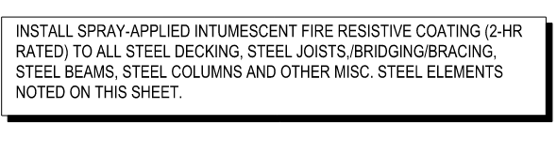
- Sheet AZ-100 can you provide additional clarity related to the sprayed fire proofing, grids 1 to 6 / A to S1 indicates concrete deck and support beams can you clarify if this area requires new fireproofing on just the beams or does it require the concrete deck also, can you clarify this area?
See item 51.
- In reference to the 087100 Door Hardware Schedule:
  - The PACS system can supply sufficient low voltage power to the electronic door locking hardware whereas the dedicated power supplies factored into the hardware sets may not be required if solely intended for the electronic hardware unless required by way of hardware warranty coverage or a special power requirement. Please advise.

Provide per construction documents

  - Are door position switches required for each PACS door? These are not shown within the 087100 Door Hardware Schedule or referenced within EE501 / Detail #4.

Provide door hardware per door hardware schedule in 087100

- In reference to Sheet EY-101:
  - Regarding the Motion Sensors shown in Rooms ‘Retail Receiving/Storage 188A’ & ‘Retail 188’:
    - Is the intent to manage these sensors via a dedicated intrusion detection system?

Yes

      - If yes, shall an arming keypad, door position switches for the entrances into these rooms, and local siren be provided?

Yes

      - If yes, how shall the system be monitored; via a PACS System interface for PD monitoring or other?

PD monitoring and monitoring in office 191 in the new kitchen

- In reference to Sheet EY-201 / Key Note #2:
  - JCI to provide a dedicated network switch for the surveillance system: Currently, JCI has a network switch & patch panel located in Building 5 Room 296C with sufficient port capacity to serve the additional cameras factored into this project. Would it be acceptable to extend off of this existing switch or is a new switch still required?

It would be acceptable to extend off the existing switch. There are currently enough available ports in the existing switch to support the addition of the 12 cameras called out in the project plans.

  - JCI to provide and install two 16TB hard drives: JCI has deployed a campus recording server head-end with spare capacity to serve the additional cameras factored into this project while adhering to the campus archiving requirements. Would it be acceptable to expand off of the existing recording server head-end or is a new recording server required?

It would be acceptable to expand off the existing recording server head-end. There is enough existing capacity in the server to support the addition of the 12 cameras called out in the project plans.

- General:
  - Regarding the PACS System:
    - If door position switches are required for each PACS door, request-to-exit motion sensors or a 2nd card reader would be required on the egress side of each PACS door. Please advise.

Provide door hardware per door hardware schedule in 08 71 00

- Section 01 00 00 (General Requirements), Article 1.2.A “General Intention,” cites “Project #438-21-112,” while the cover sheet, all drawing title blocks, and the balance of the specifications cite “VA Project #438-21-403.” Section 09 06 00 (Schedule for Finishes) cover page also lists “VA #438-21-112” with a “Date: 06-28-22” that does not match the 08-18-2026 issue date on the rest of the documents. Please confirm 438-21-403 is the correct and sole project number, and that Section 09 06 00 has been fully updated for this solicitation.

438-21-403 is the latest, correct project number. Please disregard project number 438-21-112 found on the plans and specifications and replace with 438-21-403.

- The SOW requires the Prime Contractor to “provide a list of all items specified for which no substitutions will be accepted.” Please confirm whether this list has already been compiled by the design team as a bid exhibit, or whether each bidder must independently review the ~140 specification sections and compile its own no-substitution list prior to bid.

See attached Justification and Approval for sole sourced items required for this project. All products/materials must meet the specifications.

- Phase 1 tasks include “remove and reinstall existing elevator hoistway entrance,” and Phase 1 concludes with the new N.F.S. kitchen serving the hospital “via the freight elevator.” Please confirm whether this work takes the freight elevator out of service, for how long, and what the interim/backup meal-delivery plan is to inpatient units during any outage.

The service elevator will be out of order during the time duration of the elevator entrance construction. The inpatients’ meals will be delivered via different elevator.

- During Phase 2, the existing V.C.S. Canteen is shown operating out of the vacated N.F.S. (old second-floor kitchen) space. Please confirm whether any contractor work (patching, minor MEP/finish work) is required to make that space serviceable for interim canteen use, or whether this is a VA-managed FF&E relocation outside the contract scope.

Until completion of Phases 1 and 2 are completed, the existing V.C.S. “Canteen” (food services) remains operational in its existing location on second floor and no contractor work is required to keep that space operational.
As noted on phasing plans, during Phase 2, the V.C.S. “Retail” remains operational within a reduced footprint within the existing V.C.S. space (not the old second floor kitchen). Installation of temporary wall is required as noted on phasing plans.
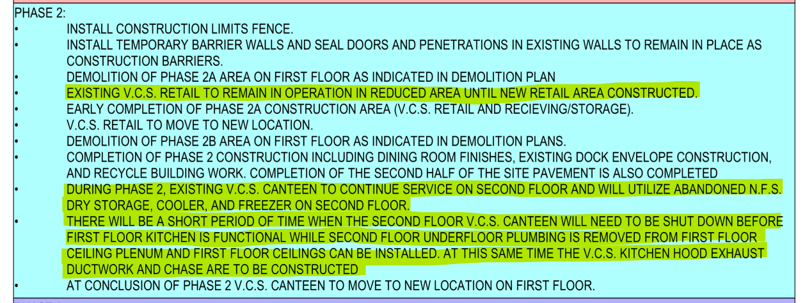

- Phase 3 notes state there will be “a short period when the 2nd-floor V.C.S. Canteen must be shut down before the move is complete.” Please confirm the maximum allowable duration of this shutdown and the required advance notice to VA Nutrition & Food Service / Canteen staff.

This occurs during Phase 2 and not Phase 3 as noted. The duration of the Canteen shutdown will be minimal time. The contractor’s schedule dictates the duration of the outage and still be able to complete the project within the period of performance. A two-week notice is required for any shutdowns.

- The SOW references “other construction projects…occurring at the same time and near the kitchen renovation space” requiring coordination. Please identify the other active or planned construction contracts/contractors in or adjacent to Building 5 so shared logistics, staging, and schedule coordination can be reflected in our bid.

There will be construction of a boiler plant to the southwest and a possible sterile processing addition to the east of the kitchen project.

- The SOW requires owner-furnished equipment to be stored on-site, once received, in humidity/temperature-controlled storage (50% RH, 60–70°F). Given the 550-calendar-day performance period and staggered FSE delivery, please confirm whether the Contractor must provide this climate-controlled storage for the full project duration (and its approximate required size), or whether VA has an existing facility available for this purpose.

The storage for owner furnished equipment is to be provided at start of construction. See answer for question #17 for location. Semi-trailer size storage area. The VA has no storage space for this equipment.

- Please confirm whether “night and weekend work” required to keep the campus functional (after-hours defined as 5:00 PM–6:00 AM) is priced as a base-bid requirement limited to specific disruptive activities (tie-ins, utility interruptions, etc.), or whether the VA anticipates a broader recurring night/weekend shift for the project duration — this materially affects general conditions pricing.

Construction will not interfere with the daily operations of the hospital. The means and methods of the work, whether it’s during normal working hours, or after hours is up to the contractor. For example, work such as utility shutdowns or loud noises and vibration work may need to be accomplished during off hours or weekends.

- Structural General Notes (S-000, ¶1.4.2 “Design Live Loads”) lists only “Loading Dock … 125 PSF.” No other area-specific design live load is stated. Please confirm the design live load(s) used for the first-floor kitchen, dining, retail, and storage areas — particularly under walk-in coolers/freezers and cook-line equipment.

The live loads identified in the General Notes apply to the new construction. The first-floor kitchen, dining, retail, and storage areas are part of the existing framing and were not designed by A/E.

- S-001 notes direct the Contractor to verify actual selected mechanical/kitchen equipment loads and locations against the structural design and to notify the structural engineer of any changed conditions. Please confirm the structural design already accounts for the specific roof-mounted MAU-5-01/MAU-5-02 units (M501) and kitchen exhaust hood/Ansul system (M402) weights, or whether this verification and notification is a Contractor submittal responsibility during construction.
The assumed weights of rooftop equipment are noted on S102. If the actual weights are more than what is noted, contact the Engineer.
- G-003 (Code Plan) classifies portions of the renovated first floor as Mercantile (M), Storage-Mercantile (S-M), Business (B), and two Assembly subtypes (A-K kitchen, A-L dining) within an occupied hospital. Please confirm the required fire/smoke-rated separations at each temporary phase-construction limit align with an approved Interim Life Safety Measures (ILSM) plan for this mixed-occupancy phased sequencing.
This is treated as a non-separated “Mixed Occupancy” including compliance with the most restrictive requirement of each individual occupancy included. However, required smoke rated partitions are noted around storage areas as required by code. Please also note that areas with an occupant load of less than 50 are incidental to the Business Occupancy classification of the entire floor.
- Specification 01 35 26 (Safety Requirements) requires ILSM measures, but we did not find a project-specific ILSM risk assessment among the solicitation attachments. Please confirm whether VA will issue an ILSM risk assessment for this project, or whether the Contractor is responsible for developing and submitting one for ICRA / Life Safety Committee approval prior to starting each phase.

A VA provided risk assessment will be conducted prior to any construction. Interim Life Safety Measures will be implemented as the need arises during construction.

- M402 (Kitchen Exhaust Hood Details) notes that hood shunt-trip breakers and “all other electric shutdowns & wiring” are “by others,” while the Ansul wet-chemical fire-suppression system appears bundled within the CF/CI food service equipment package (FS101/FS103). Please clarify the scope split between the Kitchen Equipment/Food Service installer and the Electrical subcontractor for furnishing, installing, and wiring the hood suppression system, including the shunt-trip tie-in to the fire alarm system.

The M402 drawing referenced is a mechanical drawing in which the ‘by others’ infers the Electrical Contractor performing all line voltage work for shunt trip installation and control panel power while the Fire Alarm Contractor and/or hood supplier performing the low voltage work involved in remote monitoring, pull station, and sensor installations.

See sheet FSE101 for wiring details pertaining to the hood and the fire protection system.

- Specification 11 40 00 and Dwgs FS101/FS103 identify the CF/CI (Contractor-Furnished/Contractor-Installed) kitchen equipment items, but no utility rough-in/final-connection scope is assigned on those sheets. Please confirm whether final utility connections (electrical, plumbing, mechanical) to CF/CI equipment are included in the Kitchen Equipment subcontractor's scope, or fall to the respective MEP trades.

Correct, the foodservice subcontractor is responsible for providing dimensioned rough-in drawings. ALL work is to be provided by Contractor – design documents don’t dictate separation of work between subcontractors.

- Please confirm the total exhaust airflow of the kitchen hoods scheduled on the FS-series sheets reconciles with the make-up air capacity shown for MAU-5-01 (10,000 CFM minimum outdoor air, per M501) — the FSE/hood package is furnished under a separate specification section (11 40 00) from the mechanical design and we want to confirm the two were coordinated.

Refer to drawing M301 for more detailed airflow information and space pressurization diagrams for both occupied, and unoccupied, modes of operation.

- Phase 1 includes construction of “a new open loading dock,” while the existing dock remains the only receiving point for the hospital's food service operations until Phase 1 completes. Please confirm the interim receiving/delivery plan and any temporary dock or staging area VA will make available during that construction period.

There is a separate receiving point for food service operations. Staging areas are shown on the phasing plans sheet G005 – G009.

- The master Specification Table of Contents (Section 00 01 10) lists “DIVISION 04 – MASONRY” as a header but includes no section beneath it – no masonry section appears anywhere in Volumes 1 or 2. Drawing A-450 (Keynote 4.05) calls for brick infill to match the adjacent existing wall. Please confirm whether a masonry specification section (mortar type/mix, bond/coursing match, cleaning, tuckpointing) will be issued by amendment, or clarify what standard governs this work.
Sections 04 05 13 Masonry Mortaring, 04 20 00 Unit Masonry, and 04 72 00 Cast Stone Masonry will be issued via addendum to address this. See amendment attachments.

- Division 14 – Conveying Equipment does not appear anywhere in the Specification Table of Contents (00 01 10), which proceeds directly from Division 12 to Division 21. Drawings AD-101 (Keynote 14.01B) and A-101 (Keynote 14.01C) call for removal, salvage, and reinstallation of an existing 4'x7" bi-parting elevator hoistway entrance, frame, sill, and controls. Please confirm what specification governs this life-safety-related work, including ASME A17.1 compliance, elevator contractor qualifications, and testing/inspection requirements.

This is not “life safety work” as noted. This is the removal and reinstallation of exiting materials (hoistway entrance) to match existing conditions. The A/E was not provided cut sheets/shop drawings of the existing hoistway entrance. We were instructed that another local VA project was to include a new elevator car/entrance and that we were only to call out the relocation of the exiting hoistway entrance door.
The project includes access to the new kitchen from the existing service elevator located in the center of project. The rear door is installed. The scope of the project would be opening the wall to expose the existing doors and then KONE would need to program the use of the rear doors.

- Section 02 41 00, DEMOLITION, is cited as the governing section for demolition work by Section 01 00 00 (General Requirements), Section 02 84 16, and the Seals Page consultant-responsibility list – but Section 02 41 00 itself does not appear to be included in either specification volume. The drawings carry roughly 40 individual demolition keynotes (Sheets AD-101/AD-102, and fireproofing-related removal/reinstall keynotes on A-100/A-102). Please confirm whether Section 02 41 00 will be issued by amendment, or clarify what governs demolition execution, protection of existing work to remain, and disposal requirements.
Section 02 41 00 Demolition was submitted in the original 100% complete documents but accidentally missed in the Mod #1 submittal. Reference addendum 01_2026-10-09
- Section 02 82 11, TRADITIONAL ASBESTOS ABATEMENT (full containment), is referenced within the included hazardous-materials sections as governing abatement methods distinct from Glovebag (02 82 13.13) and Transite (02 82 13.31) abatement, both of which are included – but Section 02 82 11 itself is not. Please confirm whether any asbestos-containing material on this project requires traditional/full-containment removal and, if so, whether Section 02 82 11 will be issued.

Specifications 02 82 13.13 & 02 82 13.31 are the specifications needed for the extent of the know-abatement required for the project area. See answer to question #30.

- Several specification cross-references throughout the document cite section numbers that do not match the number actually used for that same section elsewhere in the project manual – for example, Food Service Equipment is cited as Section 11 41 00 in the Table of Contents but issued as Section 11 40 00 in the specification body (and in the SOW); Low-Voltage Electrical Power Conductors and Cables is cited as Section 26 05 21 in several related-work lists but issued as Section 26 05 19; Structural Steel Framing is cited as Section 05 21 00 in one related-work list but issued as Section 05 12 00. Please confirm these are numbering inconsistencies within the same intended section (not separate missing sections), so submittals and RFIs during construction reference the correct section number.
These are simple typos.
Section 11 41 00 Food Service Equipment in the Table of Contents will be changed to 11 40 00 Food Service Equipment via addendum 01_2026-10-09

Reference to 05 21 00 Structural Steel Framing in 05 31 00 – 1.2.B will be changed to 05 12 00 Structural Steel Framing. Reference addendum 01_2026-10-09

- Drawings A-310 and A-450 (Keynote 8.05D) call for a “Coiling Fire Shutter,” and the life-safety/code plan Sheet G-003 (Keynote 8.12) shows a run of nine “Surface Mounted Fire Rated Coiling Doors” along a rated separation line. The only two Division 08 coiling-door sections included in the project manual are Section 08 33 00, Coiling Grilles (an open security grille, not fire-rated), and Section 08 33 13, Coiling Counter Doors (a small manual crank-operated counter/pass-through door). Neither section's stated scope covers a surface-mounted, fire-rated overhead coiling door/shutter of the type shown at these rated openings. Please confirm which specification governs these assemblies (e.g., a fire-rated overhead coiling door section, typically UL 10B/UL 14C-labeled with an automatic-closing fire-alarm-interlocked operator), or advise if Sections 08 33 00 / 08 33 13 are intended to be revised in scope to cover them.
Coiling “Grills”181A and 181B (as indicated in door schedule) are governed by section 08 33 00 Coiling Grills and are open grills.
The nine (9) Coiling Fire Shutters/Doors 139C (as indicated in door schedule) are governed by 08 33 13 Coiling Counter Doors and are 90 minute rated as scheduled and as specified. Nowhere is it noted, detailed or specified as “surface-mounted” as noted in question above. Reference details C4 on sheet A-310, D5 and F5 on sheet A-601, keynote 8.05D and door schedule on A-601. Section 08 33 00 – 2.4.A.2 calls for “Installation: Inset with window Jambs” and not “surface mounted”. The details also indicate mounting within jambs. These are specified as automatic closing via fusible link and not via fire-alarm interlock to save money. Fire/smoke alarm interlock is not required as the aluminum storefront provides the smoke barrier.

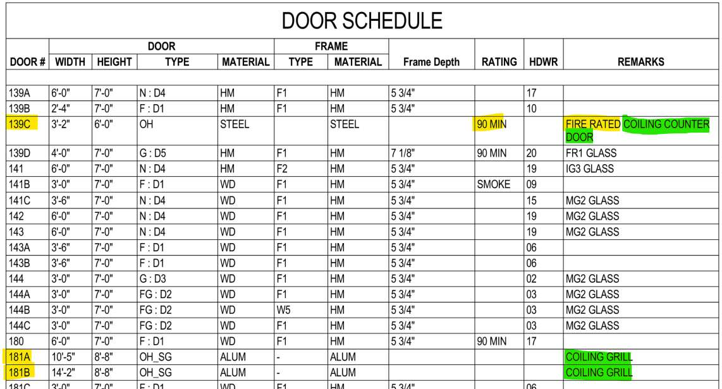

- These mini-split condensers are where the building addition will be going and at least one seems to serve a lower level electrical room that is to remain in operation. I do not see any demolition/relocation of either of these units indicated on the plans. Please see attached photos and advise if this should be part of the bid or if the Owner will be taking care of this separate from the contract.

Reference addendum 01_2026-10-09 for information for relocating these condensing units along with any temporary measures required for construction phasing.

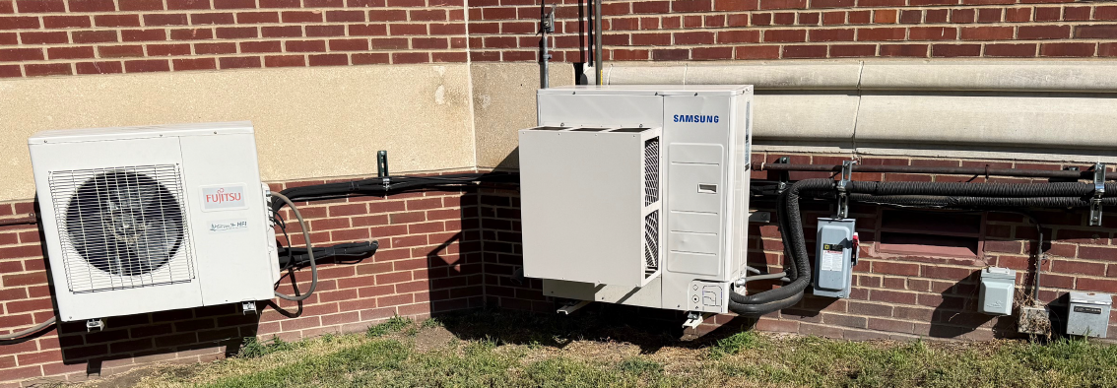

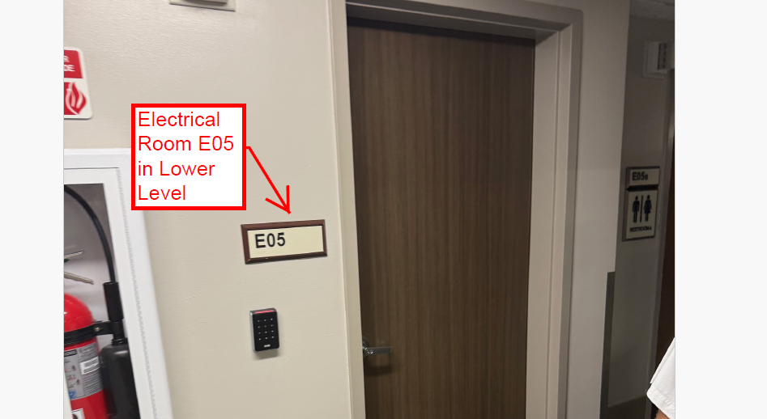
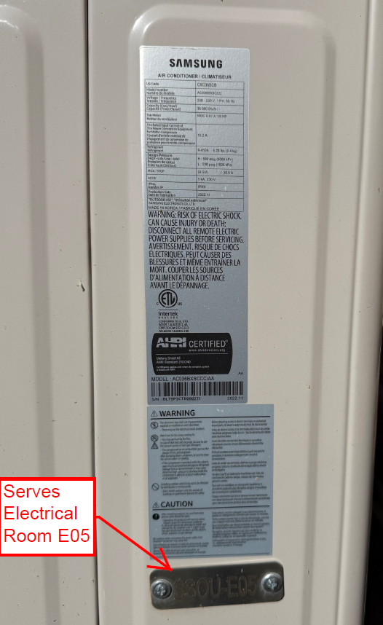
- Sheet A-101 Keynote 11.10 states retail fixtures and equipment are provided by and installed by Owner, and keynote 12.02 states dining tables and chairs are provided by and installed by Owner. Scope of Work Paragraph 8 includes installation of owner furnished equipment in the Contractor’s Scope, and Paragraph 11 requires the Contractor to provide humidity – and temperature – controlled storage at 50 percent relative humidity and 60 to 70 degrees Fahrenheit for owner furnished equipment. Please provide a complete equipment responsibility matrix identifying, for every item, whether it is furnished by Owner or Contractor and installed by Owner or Contractor, and confirm the duration and quantity of conditioned storage the Contractor must provide.

Sheet AI100, FS101, and FS103 are a matrix that identifies scope of work. Keynote 11.10 is to notify the contractors that the owner may need to be in the finished area to install fixtures and equipment.

Keynote 11.10 pertains to retail fixtures that include items such as display racks/shelves, hangars, etc. that will be OFOI but the contractor may need to coordinate with (we were not provided any specifics).
Keynote 12.02 pertains to tables/chairs in the dining room that will also be OFOI.

- The Sheet A-601 Door Schedule leaves the hardware set column blank for Doors 139C,181A,181B, 181E, 181F, 188D and 188E. Doors 181E, 181F, 188D and !88E carry 45-minute fire ratings; Door 139C is a 90-minute fire-rated coiling counter door with no frame type assign; and Doors 181A and 181B are aluminum coiling grilles with no rating assigned. Please assign a hardware set from Section 08 71 00 to each of these openings, confirm the frame type for Door 139C, and confirm the fire rating requirement for Doors 181 A and 181B. Please also identify the doors or access panels to which Hardware Set 13 applies and the quantity of access panel cylinders required.
Doors 139C are nine (9) fire rated coiling door/shutter and are addressed in 08 33 13 Coiling Counter Doors. There is no additional frame requirement as the door/shutter has integral side rails and no additional door hardware required within 08 71 00 Door Hardware.
Doors 181A and 181B are non-rated coiling grills and are addressed in 08 33 00 Coiling Grills. There is no additional door hardware required within 08 71 00 Door Hardware.
Doors 181E,181F, 188D and 188E are to have hardware set 11.
“Access Panels” requiring hardware set 13 are called out on sheet A-102.

- Sheet A-501 requires 2-hour spray-applied fireproofing to be installed on an existing steel column and fire-rated sealant between the column and adjacent CMU. Please provide: (a) the required surface preparation, including whether existing fireproofing must be removed; (b) the hazardous materials survey results for the existing fireproofing at this location; (c) if asbestos-containing material is present, the abatement scope, containment requirements and the party responsible; and (d) confirmation of the required UL design number for the 2-hour column assembly.
- Surface preparation is dependent upon individual manufacturer and their system (we did not specify proprietary system).
- No existing fireproofing – this is “new” applied fireproofing.
- See response to (b) above.

- Scope of Work Paragraph 10 limits work to Monday through Friday with no weekend or holiday work and establishes a 550 calendar day performance period. Scope of Work Paragraph 2 requires work in occupied areas to be performed between 5:00 PM and 6:00 AM, including weekends. Please clarify: (a) which paragraph governs; (b) the specific activities the VA requires to be performed outside normal working hours; (c) whether premium time for such work is to be included in the base bid; and (d) whether the 550 calendar day duration assumes single-shift or multi-shift execution.

Working after hours from 5pm to 6am is required in the ground floor warehouse for fire proofing activities and any other work that cannot be accomplished in a hospital during normal business hours. The VA is flexible on work hours if they are different from what is posed. No special pay is associated with working after hours or on the weekends. 550 calendar days remain unchanged.

- Ref drawing FS103- The schedule indicates that Items 203, 204B, and 205B are to be furnished and installed by the contractor, while Items 204A and 205A are to be furnished by the owner and installed by the contractor. To clarify, will the owner be providing the condensing units for the walk-in refrigerator/freezer?

These items will all be furnished and installed by the FSEC. Reference addendum 01_2026-10-09.

- Ref drawing AD101- Keynote 2.10 requires 5” of concrete topping to be removed. Is the topping pour over an existing structural concrete slab? Is there a full basement below the 1st floor phase 1 and 2 areas? If an existing structural slab is present below the 5’ topping scheduled for removal, will the floor require a concrete infill to repair the area and if so how thick will the new infill be?
Yes, the 5” of concrete to be removed is infill over a structural floor. Yes, there is a full finished floor below. The 5” of concrete topping to be removed is a combination concrete infilled depressed slabs, and raised concrete curbs in the existing floor. Yes, the floor will need to be repaired/leveled after removals with a topping depending on the removal methods used by the contractor.
- Ref AD101- What is the manufacturer of the existing elevator that requires relocating the Bi-parting door? Will the elevator cab itself require a new door or will the car door also be relocated? Will elevator spec be provide.

See answer to question #74

- Ref drawing A-101 & FS-101- Will the VA be providing the Bio-Hazard Cooler as it’s not shown on any equipment schedules
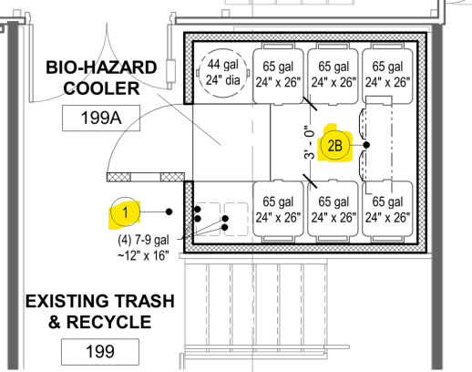
The bio-hazard cooler “is” shown and called out. As noted on sheet FS104 the bio-hazard cooler in Existing Trash & Recycle room 199. On sheet FS101, these equipment items #1 and #2B are clearly identified and scheduled as “Contractor Furnished/Contractor Installed”

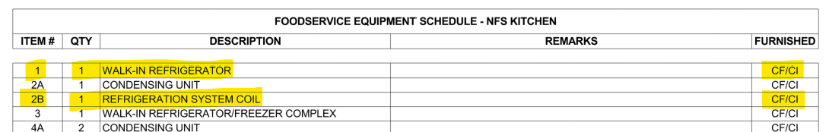

Also, the cooler appears to be installed at floor elevation in trash recycling rm 189 which is 3’-5” lower than finish grating elevation. No. It is not shown 3’5” lower. It is shown at the raised grating elevation – see clips below. This is pretty clear. The existing grating is extended to the south to accommodate setting the new coller on top of the grating. It appears one would access the cooler from the grating. Will the cooler mount on the floor in trash recycling and if so how will it be accessed from the grating elevation? As you can see in the clip below it is access from the raised grating. It sits “ON” the grating. See below.
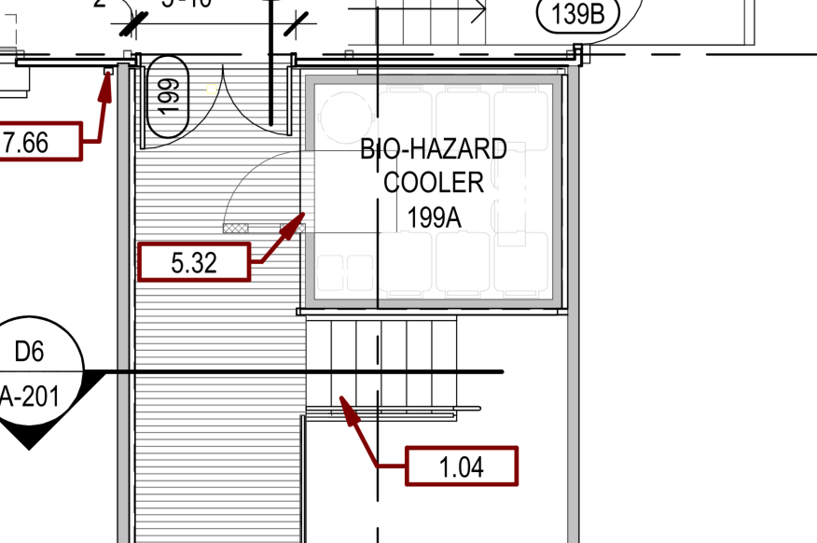
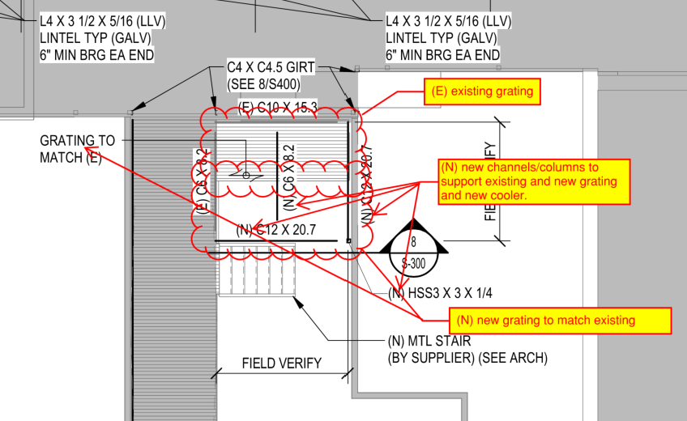

88. Ref drawing A101 & Spec 08 33 13- Windows W12 in hallway 139 appear with a fire shutter per detail D5 and F5 on drawing A-601. Are these shutters to be manually operated?
These “windows” W12 are the windows that were requested by VCS and VA to provide indirect lighting into the dining room. The fire shutters are scheduled as “139C” and provide the 90 minute protection for the windows W12. As addressed in response to question #78 the fire shutters are manual operated with fusible link activation.
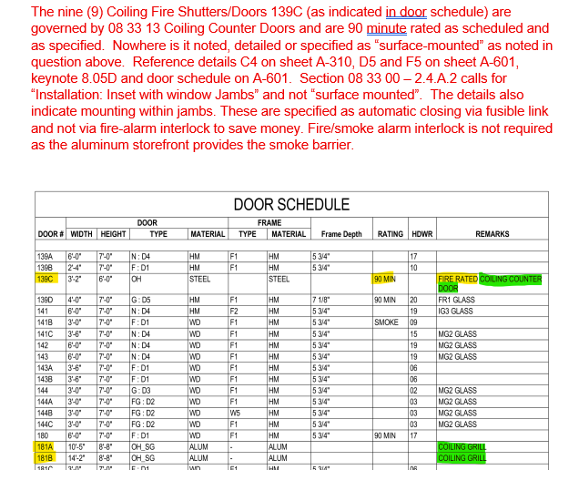

89. Civil sheets show VA #438-21-112 with 2022 issue dates; all other disciplines show VA #438-21-403, Mod #1 (08/18/26 to 08/28/26). Confirm the civil sheets are current and part of this contract, including the new loading dock paving scope.
Yes. The civil sheets are current and part of this contract, including the loading dock. Addeddum #01 changed the issue date for civil sheets to 8/18/26.

90. Part 1 of the drawing set (cover, drawing index, G-002 referenced on A-101 and A-310, phasing, ICRA and life safety plans) and the project manual were not in the documents reviewed. Provide the complete drawing index, G-series sheets, specifications and the wage determination.
Original CD set dated 6/28/22 issued to the VA included these noted sheets and the project
manual volumes 1 and 2. Updated set dated 8/19/26 that incorporated the applied fireproofing
per Mod 01 also included these noted sheets and the project manual volumes 1 and 2.

91. Plumbing demolition references Phases 1, 2A, 2B and 3. Provide the phasing plan with durations. Confirm whether the existing 2nd floor kitchen stays operational until the new kitchen is commissioned and whether any temporary food service is required of the contractor.
See phasing plan sheets G-005 – G009. Duration of project is noted in VA’s scope description.

92. Provide the UL design number and required dry film thickness for the 2-hr spray-applied intumescent coating on the existing H-series joists, bridging and deck. Confirm whether SFRM is acceptable where concealed above ceilings.
U.L. design numbers are proprietary for individual manufacturers/products. This is against VA policy to sole source individual manufacturers without reason. The documents indicate the required fire rating, and the type and size of individual steel members. The manufacturers are to provide compliant system for the application.
The type of applied fireproofing is called out in the drawings (intumescent coating vs spray applied fireproofing).

93. Ground floor work is limited to 4PM to 7AM with nightly turnover. Confirm nights per week, weekend availability, the nightly turnover standard, and the owner furniture relocation sequence.
The ground floor work is in the warehouse. The VA will move items for the spray fireproofing.

94. Provide the hazardous materials survey (plaster, VCT and sheet vinyl mastics, clay tile walls, roofing, Kalwall, sealants). Confirm whether abatement is in this contract.

The scope of abatement is called out in 02 82 11 – 1.1 (issued in addendum 01), 02 82 13.13 - 1.1, and 02 82 13.31 - 1.1 The scope of lead-based paint removal is called out in 02 83 33.13 -1.1.The scope of handling & disposal of fluorescent tubes and batteries is called out in 02 84 16.

95. Condensing unit locations conflict: FS102 states inside the mechanical room, the FS300 detail shows roof-mounted units, and the mechanical schedules show dry cooler FC 5-02 serving walk-in coolers. Confirm refrigeration system type (air-cooled vs glycol-cooled) and locations.
See attached addendum 01.

96. NFS condensing units 2A, 4A and 5A are CF/CI while VCS units 204A and 205A are OF/CI (their coils 204B and 205B are CF/CI). Confirm furnish responsibility.
Responsibility for furnishing and installation is noted in drawing sheets. See attached addendum 01.

97. The exhaust schedule shows hood 76 L1 at 11,813 CFM (likely 1,813) and hoods 216 and 238 at 0 CFM with 12x12 placeholder collars. Provide final hood exhaust data and hood lengths.
See exhaust schedule in addendum 01.

98. Confirm responsibility for gas shutoff valves and electrical shunt-trip / contactor interlocks on hood suppression activation (Div 11 vs Div 22 vs Div 26).
See sheet FSM101 and FSE101 details. Natural gas solenoid valve to be furnished by FSEC and installed by Division 22. Installation of shunt trip, along with all wiring and interlocks, to be installed by Division 26. (ultimately division/separation of work is general contractor responsibility)

99. Approximately 200 items are OF/CI. Provide the owner equipment delivery schedule. Confirm receiving, storage, uncrating and debris removal are by the contractor, and identify all OF/OI items.
Responsibility for furnishing and installation is noted in drawing sheets.

100. Door 139C (90-min fire-rated coiling counter door, 3'-2" x 6'-0") is listed once in the door schedule but tagged at about 9 locations on A-101. Confirm quantity.
These are all the same coiling counter door. Quantity/locations are called out on sheet A-101.

101. Hardware sets 01 to 20 are referenced but no hardware schedule was provided. Provide the hardware schedule and identify doors requiring access control (VA PACS) and automatic operators.
Door hardware sets are referenced in Door Schedule on sheet A-601. Hardware specifications and hardware schedule are section 08 71 00.

102. Confirm W12 glazing (IG1 with film AWF-1 vs IG2 spandrel) and quantity. Confirm existing frames remain at W1 and W12 and at the spandrel infill locations (5.12, 5.12A).
As noted in Window Types on A-601:
Window type W12 is to get IG-1 glazing (1” clear insulated glass with applied film AWF-1) this is to achieve a translucent glass effect – not an opaque spandrel glass.
Window type W1 is existing window frame with glass replaced with new IG2 glazing and reapplied muntin grills.
As noted above, window type W12 is NOT spandrel glass.
Window type W12 is new aluminum storefront as noted in associated details F% and D7 on A-601.

103. Provide specifications for the dock lift (11.52) and dock leveler (11.53), including capacity and whether a pit is required.
Dock lift is specified in 11 13 23 Portable Dock Equipment. Dock leveler is specified in 11 13 19 Stationary Loading Dock Equipment

104. Identify the "adjacent project" referenced in the traffic control notes and the requirements for maintaining loading-dock access during construction.
See answer to question 62. Design team was directed by VA during design that the two “existing” overhead doors / loading dock bays were to remain accessible during phase1 construction (reference phasing plans and construction fence locations for phase 1). Design team was directed by VA during design that the two “new” loading dock bays were to remain accessible during phase 2 construction (reference phasing plans and construction fence locations for phase 2).

105. Confirm the delegated design scope for the light gauge moment connection to the existing pan joist slab and the supplier-designed stair and rail systems.
Contractor shall provide stamped calculations for the light gauge moment connection at the Retail storefront as noted on sheet S-101 (reference architectural drawings for full extent of retail storefront wall). Contractor shall provide stamped calculations for all metal railing systems.

106. For new openings in the existing deck/slab (demo 2-1/2" slab between joists), confirm shoring and protection requirements and whether spaces below are occupied.
Shoring and protections systems are part of the contractor’s means and methods. The “space below” is shown in the documents.

107. Confirm the extent (SF) of roof removal to deck and new TPO roofing. Identify the existing roof warranty holder (mechanical notes require the current roofer to maintain warranty).
Extents of removals and new roofing work are in the drawings. Bidders/contractors are responsible for calculating quantiles. Roof warranty has expired.

108. General roof notes reference a 4/12 slope and ridge/soffit venting, which conflict with the tapered TPO system. Confirm these notes do not apply.
General note D on A-102 would not be applicable as all slopes ARE noted otherwise.
General note B on A-102 would not be applicable as there are no ridge or soffits.

109. RCP general note H references paint "PT-??". Provide the designation.
All bulkhead faces are to match the color of the adjacent wall surface unless noted otherwise on the drawing/schedule.

110. For HEX 5-01A/B steam-to-water heat exchangers, confirm steam source, pressure, tie-in location, condensate return route and allowable shutdown windows.
Refer to drawing MP001, specifically key notes #1 through #4, that answer all questions above. Point of connection into existing tee from 60 psi main into a new pressure reducing station to reduce to 15 psi as indicated on that drawing. Premium time should be assumed for tie-ins that will create any steam outage.

111. Confirm available capacity and spaces in existing SWBD 5-1 and SWBD 5-2 (West) for new Eaton KD and feeder breakers, and confirm outage windows.
8(each) 400-amp Spaces available in SWBD 5-2. Outage windows need to be coordinated with VA.

112. Note W requires connection to building emergency power. Identify the equipment and the essential electrical system branch.
Refer to Electrical Equipment Schedule on EE600 for circuiting requirements

113. Confirm the extent of medical gas demolition, zone valve impacts outside the work area, and NFPA 99 verification responsibility.
Medical gas work is limited to demolition of an abandoned valve box, as shown on drawing PGD101. There are valves available to keep impact on the existing system minimal but is no guarantee that those will hold onto full line-pressure. Contractor should include a medical gas certifier to be available for 1-day in case any existing system loses pressure and requires recertification and/or if temporary services (by others) are required due to faulty or non-existent valves.

114. Provide grease interceptor size, location and connection details (schedule references full trap below grade). Confirm excavation and restoration limits.
Refer to ‘Grease Interceptor Schedule’ on drawing P500 for basis-of-design models. Note waste/vent riser diagram P302 showing locations of both Grease Interceptors (GI 1-01 and GI 1-02) that are located above floor level directly under sinks served. Only notes I found about traps below grade was on ‘Floor Sink Schedule’ on P500 but does not directly apply since all floor sinks for this project are being installed on floor above grade.

115. Confirm the applicable Davis-Bacon general decision and modification (Building, Minnehaha County SD) and whether a Heavy/Highway decision applies to civil paving.
See applicable wage determination attached to solicitation.

116. Walk-ins with stainless steel floors sit on existing precast plank. Confirm whether slab depressions are required or insulated floors with ramps are intended.
See detail SD-185 on sheet FS403 for floor detail. See section 11 40 00 - 2.7.D for walk-in cooler/freezer floor requirements.
117. Confirm owner-provided items (signage OFCI; telephones, computers and furniture VV) and whether the contractor installs wall-mounted TV brackets (A5210 VV, A5220 CC). See sheet FSM101 and FSE101 details. Natural gas solenoid valve to be furnished by FSEC and installed by Division 22. Installation of shunt trip, along with all wiring and interlocks, to be installed by Division 26. (ultimately division/separation of work is general contractor responsibility)
OFCI matrix is noted on the plans. Phones, computers, and furniture are owner installed. TV brackets are typically contractor installed. See specifications and details.

118. Confirm VA CQC system manager and SSHO staffing requirements (dedicated full time vs dual role) for this contract.
See answer to question #24.

119. Confirm the VA fire alarm manufacturer and head-end, whether programming must be by the station's existing vendor, and the security / access control scope.
See answer to question #43.

