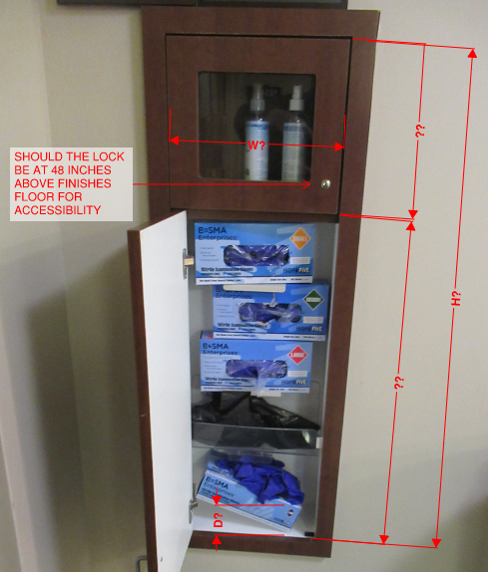

Roughly 40 ½



6 inches to outside of frame



29 inches



11 ‘’ inches



12 inches

43 ½ inches

