Solicitation 36C26321R0124
Project 656-19-306 Renovate Building 28 1st Floor East for RRTP
Solicitation Questions and Government Responses:
- It is becoming increasingly difficult to obtain Past Performance Questionnaires from Contracting Officers on a project-by-project basis, especially when they have already filled out a CPARS evaluation for us. In light of this, will the VA accept completed CPARS evaluation forms in lieu of the provided Past Performance Questionnaire Form?

Answer: In accordance with the solicitation Paragraph 11.3.1.3.3, In making a decision on the award of an individual order, the Contracting Officer may consider factors such as Past Performance on previously awarded contracts and task orders, review completed CPARS, and take into consideration, quality and timeliness of work performed, and/or other factors that may be relevant to the award of this particular

- Attachment F(a) - Drawings Mechanical gives us an error when opening the file after downloading. Can you please reupload this file?

Answer: Republished Mechanical Sheets M000 through MP101 (Attachment F(a))-except MH111 which is included on separate attachment as revised drawing.

- The Standard Form 1442 states that the project must be completed in 305 days after NTP. This is corroborated by the Price Schedule Sheet. The scope of work lays out a schedule that includes 330 days from date of contract award, not NTP. In the “Basis of Award” factor 11.3.1.2 the schedule requests a schedule that meets 330 day time frame for project completion that starts with the Notice to Proceed. Which is requested, a 330 day schedule from Notice of Award or a 305 day schedule from Notice to Proceed?

Answer: According to the solicitation Paragraph A.4, Scope of Work, Paragraph C, the construction completion is Contract Award +330 days, and 305 days from Notice to Proceed. The evaluation factor states that you are submit a project schedule that meets the 330-calendar completion. There is not a discrepancy.

- The Demolition Plan Keyed Notes on drawing AD111 do not appear to be positioned correctly. While the intent may be assumed on many of these notes, several of the missed locations make interpretation less conclusive. Please reissue the drawing with keyed notes in the correct locations.

AE Response: This sheet has been revised and reissued in Amendment 0005.

- The last page of the solicitation document is labeled as “Page 17 of 22.” Are there any additional pages not distributed? If so, could the VA please provide these final 5 pages?

Answer: The solicitation document has a glitch in the page numbering. The solicitation has 22 pages, please review the Table of Contents to show which section of the solicitation is found on which page.

- Drawings S000, S100, S110, S200, S210, S300, and S301 are marked “NOT FOR CONSTRUCTION.” Please confirm that these drawings are intended for construction and that no changes are anticipated to the project design.

AE Response: These sheets are reissued without the “Not for Construction” text, see attachments in Amendment 0005.

- Please confirm this project will be tax-exempt, the VA will issue a tax exempt certificate

VA Response: In accordance with MN Department of Revenue Notice #17-10, The project is not tax-exempt, and VA will not issue a tax exempt certificate.

- Please confirm any temporary construction fence around the construction area must be 7’ tall.

AE Response: Refer to specification section 01 00 00 paragraph 1.6.M.

- Please confirm occupied temporary construction fence areas must have a man-gate with panic egress hardware.

AE Response: Refer to specification section 01 00 00 paragraph 1.6.M.

- Please confirm working hours are to be 8:00am to 4:30pm without exception

AE Response: Refer to specification section 02 82 11 paragraph 3.7.3 Work Shifts.

- Please confirm if temporary construction power must be metered.

AE Response: Temporary construction power is to be metered per section 01 00 00 paragraph 1.21 C.

- Please confirm all roofing activities will require hard rails, not flagging per OSHA regulations, must be placed 6 feet from the leading edge, or 100% harnessed.

AE Response: OSHA requirements applicable per section 01 35 26 paragraph 1.1.G.

- Please confirm that only Benjamin Moore paint is allowed.

AE Response: References to paint manufacturers are provided for color identification purposes. Refer to applicable paint specifications for performance requirements.

- Will the VA provide all utility locates?

AE Response: Yes, the VA is to perform utility locates.

- Refer to Spec Section 01 35 26, paragraph 1.7 “SITE SAFETY AND HEALTH OFFICER” (SSHO) AND “COMPETENT PERSON” (CP): Can the project superintendent also perform the role of SSHO.

AE Response: No. Refer to specification section 01 35 26 paragraph 1.7.C.

- 1Refer to Sheet GC011 Infection Control & Phasing. Detail #1 Lower Level does not have any specific Phasing Plan. Please confirm that the lower level can be completed as a single Phase, concurrently with work on the other floors.

AE Response: Additional phasing information is attached on Amendment 0005.

- Refer to Sheet GC011 Infection Control & Phasing. Detail #3 First Level appears to have (3) main phases, Link Corridor, Elevator Lobby, & Balance of the 1st Floor. Please confirm that the area shown as “E” can be completed as a single Phase, concurrently with work on the other floors.

AE Response: Additional phasing information is attached on Amendment 0005.

- Refer to Sheet GC011 Infection Control & Phasing. Detail #2 Second Level does not have any specific Phasing Plan. Please confirm that the second level can be completed as a single Phase, concurrently with work on the other floors.

AE Response: Additional phasing information is attached on Amendment 0005.

- Mechanical Phasing Plans. The Mechanical Phasing Plans have not been included with the Construction Documents. Please provide Mechanical Sheets M000 through MP101.
AE Response: Republished Mechanical Sheets M000 through MP101 (except MH111 which is included on separate attachment as revised drawing)

- Demo and removal of existing AHU’s will cause an extended outage. No temp AHU’s are shown/designed to be required while new AHU’s are installed? Please confirm at least one AHU can be out of service for a month at a time.

AE Response: Refer to drawings MD131 through MH134 (8 drawings) which show four phases of construction and temporary ductwork required from each existing, or recently replaced, AHU during the construction process to back-feed areas affected by new AHU replacements. This method will utilize the 3 of 4 remaining AHU’s in each phase to temporarily serve entire building to avoid need for a temporary AHU and associated utility connections. This phasing will occur in parallel with main project phasing shown on architectural plans and will require a complete rebalance of all affected spaces before and after each AHU replacement.

- Demo and removal of existing AHU’s will cause an extended outage. No temp AHU’s are shown/designed to be required while new AHU’s are installed? Please provide a design for any temporary AHU units required for the AHU’s replacement.

AE Response: Refer to drawings MD131 through MH134 (8 drawings) which show four phases of construction and temporary ductwork required from each existing, or recently replaced, AHU during the construction process to back-feed areas affected by new AHU replacements. This method will utilize the 3 of 4 remaining AHU’s in each phase to temporarily serve entire building to avoid need for a temporary AHU and associated utility connections. This phasing will occur in parallel with main project phasing shown on architectural plans and will require a complete rebalance of all affected spaces before and after each AHU replacement.

- Refer to Sheet FP 131, KN #4 specifies to remove all existing Victaulic Fittings and replace with welded fittings. Please provide a quantity, type, and sizes of all existing Victaulic fittings requiring replacement, for accurate pricing.

AE Response: That key note’s intent was to have contractor provide welded fitting for all new piping, including tee connection points into existing mains. Existing mains that do not interfere with new construction may remain as is. Contractor will also be responsible to temporarily relocate heads as required for construction phasing, but any temporary piping will not require welded fittings.

- Refer to Sheet FP 131, KN #4 notes “VA St Cloud does not allow use of Victaulic fittings so that welding of fittings will be required.” Please confirm threaded or flanged fittings/connections for the sprinkler pipe will be approved in lieu of welding.

AE Response: Piping that is 2” and smaller may utilized threaded fittings, but all piping larger than 2” must be welded.

- Refer to Sheet S200, Details 1,2 & 3 indicate substantial work required in the finished basement ceiling to complete. When can the waste piping work be performed?

AE Response: Additional phasing information is attached on Amendment 0005.

- Refer to Sheet S200, Details 1,2 & 3 indicate substantial work required in the finished basement ceiling to complete. What VA restrictions are to be anticipated?

AE Response: Spaces are required to remain operational. Off-Hours and/or weekend work may be necessary

- Refer to Sheet PP101 Basement Plumbing Floor Plan. All work shown on this plan is above the basement ceiling. Has the MEP been coordinated to allow for the new waste piping installation?

AE Response: Areas were field verified to the best of the design team’s ability without using any destructive measures for investigation. Refer to keynote #10 that depicts the removal of existing plaster ceilings above lay-in tile ceiling to gain additional space for ceiling plenum coordination.

- Refer to Sheet PP101 Basement Plumbing Floor Plan. All work shown on this plan is above the basement ceiling. Please confirm none of the piping shown is below the basement SOG, no concrete sawcutting is required for relocation of the sewer main.

AE Response: Correct, no piping shown on drawing PP101 is underground.

- Refer to Sheet PP101, KN #9 & 11 indicate that congestion, structural beams, & plumbing piping height, potentially could require new ceiling soffits. Please provide all required new soffits and their construction on the reflected ceiling plans.

AE Response: Existing conditions will require design coordination in the field by contractor as required to minimize the need for the addition of soffits. Should potential conflicts exist which require utilities to extend below the ceiling plane the contractor is to document the condition prior to commencing construction and any potential rerouting required for the review and approval of the COR or so as to coordinate the installation of the utilities with the location of soffits to be added to the project scope, and/or design revisions as directed by the Architect /Engineer.

- Refer to Sheet PP101, KN #10 indicates the possibility of encountering a plaster ceiling containing asbestos above the existing ACT ceiling system, contractor to “coordinate testing of those ceilings…” Please confirm any asbestos abatement required will be performed under a Change Order to this contract or provide an Asbestos Report and quantities to be abated.

AE Response: See Attachment 0-Asbestos, Lead Survey-17 pages on Amendment 0005.

- Please provide an acceptable location to set a dumpster for project demolition activities?

AE Response: The CONTRACTOR may locate the dumpster for project demolition within the fenced-in space identified as “Lay Down Space” on Sheet GC012, Construction Phasing Plans.

- Please provide any reclamation required for the dumpster area location.

AE Response: Construction dumpster to be located within fenced construction area. This area is to include new construction requirements as identified on the construction documents and the contractor is to restore the area to it’s original condition upon completion of work.

- Refer to Sheet MH400, which depicts new 4” CWS & CWR piping running through the crawlspace that has asbestos containing dirt. Please provide any asbestos abatement or precaution measures required.

AE Response: Clarification is included in Amendment 0005 attachments.

- Refer to Sheet AE602, Opening Schedule. In the Comments Column, there are (7) openings requiring “M.H. Series Door (Door Within Door)." Please provide additional clarification for this requirement.

AE Response: Clarification is included in Amendment 0005 attachments.

- Refer to Sheet MH400. FC 28-1 is shown located on “9” Line, north of “A” Line. The Civil Site Plan does not depict FC 28-1 on the plan, no concrete pad is specified. Please include any required concrete pad for FC 28-1 on the Civil Plan.

AE Response: Sheet CJ101 is to be revised as shown below in Red.
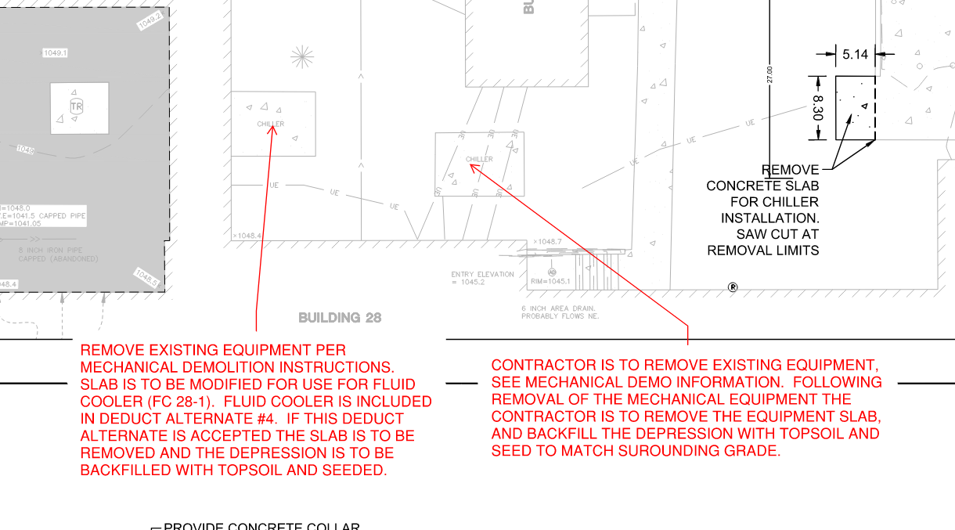

- Refer to Specification Section 05 12 00, Paragraph 2.4 Finishes, lists finishes for the structural steel. Please confirm the steel beams specified under the AHU’s in the attic space do not require galvanizing, shop primed is an acceptable finish.

AE Response: Shop primed is an acceptable finish.

- Will 7’ tall fencing be required around the dumpster location?

AE Response: Yes, dumpsters are to be fenced in and are considered part of the area of construction.

- Refer to Sheet FP 131, KN #4 specifies to remove all existing Victaulic Fittings and replace with welded fittings. The existing pipe is designed for the Victaulic Fittings as installed. Please confirm the VA price estimate includes the specified removal & replacement of the entire attic sprinkler system for the new fittings/connections desired.

AE Response: That key note’s intent was to have contractor provide welded fittings (for pipes larger than 2”) for all new piping, including tee connection points into existing mains. Existing mains that do not interfere with new construction may remain as is. Contractor will also be responsible to temporarily relocate heads as required for construction phasing, but any temporary piping will not require welded fittings.

- Refer to Sheet HA001, Hazardous Plan Note #2 refers to an existing Asbestos Inspection Report dated 5-4-17. Please provide a copy of the Asbestos Inspection Report dated 5-4-17.

AE Response: See Attachment 0-Asbestos, Lead Survey-17 pages on Amendment 0005.

- Refer to Sheet MH602 Chiller Schedule. Please include the minimum Full Load Efficiency (EER) and part load efficiency (IPLV) requirements to the chiller schedule.

AE Response: Equipment schedule on drawing MH602 is updated in Amendment 0005.

- Refer to Spec Section 23 64 00 Packaged Water Chillers. Please add the sound power values to the chiller spec 23 64 00

AE Response: Specification 23 64 00 has been revised, see attachment in amendment 0005.

- Refer to Sheet MH602 Chiller Schedule. A VFD cannot be added to the Daikin Model AGZ211E scroll compressors, there are enough steps of control for the chiller with multiple scroll compressors. Please confirm HGBP for capacity control at low loads will be acceptable.

AE Response: Use of hot gas bypass will be acceptable. Equipment schedule on drawing MH602 is updated in Amendment 0005.

