**GENERAL INFORMATION**

1. Title of Project: Building 5 Halls and Walls

2. Scope of Work: The contractor shall provide all resources necessary to accomplish the deliverables described in this statement of work (SOW), except as may otherwise be specified.

3. Background: This project is broken into several phases described below:

**Phase One:** Demolition of existing flooring, floor preparation and replacement flooring. Wall covering removal, replacement wall covering, provision of acrovyn wall protection and corner guards and paint. Removal of existing handrails/crash rails and replacement. Renovation and provision of new finishes for museum display cases. Demolition of existing doors and replacement of fire doors and office doors. Provision of and installation of new ceiling grid and ceiling tiles. Provision of and installation of new lighting for the following areas on Ground Floor, Building 5:

* Main Entrance (F04, F03, F04A), Corridors (C01, C02, C03, C04) and Main Elevator Lobby (C30).
* Primary Care Waiting Area, Ground Floor (B76), Corridors (C20, C21, C18)

**Phase Two:** Demolition of existing flooring, floor preparation and replacement flooring. Wall covering removal, replacement wall covering, provision of acrovyn wall protection and corner guards and paint. Removal of existing handrails/crash rails and replacement for the following areas on 2nd and 3rd floor CLC and Med Surgery inpatient rooms, Building 5:

CLC Rooms:

* Corridors: 291-5, 396-5
* Nurse Areas: 288-5, 388-5
* CLC Common Areas: 256-5, 275-5, 361-5, 377-5
* CLC Inpatient Bathrooms: 248A-5, 249-5, 272A-5, 274A-5, 276A-5, 281A-5, 283A-5, 289A-5, 252A-5, 254A-5, 263A-5, 265A-5, 353A-5, 389A-5, 357A-5, 359A-5, 365A-5, 367A-5, 374A-5, 376A-5, 378A-5, 383A-5, 385A-5
* CLC Inpatient Rooms: 248-5, 272-5, 273-5, 274-5, 276-5, 281-5, 282-5, 283-5, 284-5, 289-5, 290-5, 252-5, 253-5, 254-5, 263-5, 264-5, 265-5, 266-5, 353-5, 389-5, 390-5, 357-5, 358-5, 359-5, 365-5, 366-5, 367-5, 368-5, 374-5, 375-5, 376-5, 378-5, 383-5, 384-5, 385-5, 386-5

Med Surg Rooms:

* Lobbies 246 and 395
* Inpatient Corridors: 287, 287A, 394, 395A
* Inpatient Rooms: 203, 204, 205, 206, 207, 208, 230, 231, 232, 233, 234, 235, 236, 237, 303,304,305,306,307,308,334,335,336,337,338,339,340,341
* Conference Rooms: 331-5, 227-5
* Family Waiting Rooms: 202, 302, 228

**Phase Three:**

Demolition of existing flooring, floor preparation, and replacement flooring. Replacement of expansion joints. Demolition of existing and provision of new security barrier for 401. Wall covering removal, replacement wall covering, wall protection and paint. Removal of existing handrails/crash rails and replacement. Provision of and installation of new ceiling grid and ceiling tiles. Provision of an installation of new window sills and window shades. Provision and installation of new acrovyn doors. Provision of and installation of new lighting for the following areas on 4th Floor, Building 5:

* Lobby: 485
* Corridors: 487, 488, 484, 483, 483A
* Waiting Rooms: 473, 445, 403, 408
* Check-In Room: 401
* Window Shades in the following Rooms will be demolished and replaced in the following rooms: 480, 478, 477A, 477B, 477C, 477D, 447E, 447G, 447H, 475, 473, 472, 471, 470, 469, 468, 467, 466, 465, 464A, 464C, 464B, 463B, 463C, 463A, 462, 461, 460, 459, 458, 457A, 455, 451, 450, 449, 448, 447A, 447, 446A

**Phase Four:** Demolition of existing flooring, floor preparation, and replacement flooring. Wall covering removal, replacement wall covering, provision of acrovyn wall protection and corner guards and paint. Removal of existing handrails/crash rails and replacement. Provision of and installation of new ceiling grid and ceiling tiles. Provision of an installation of new window sills and window shades. Provision and installation of new acrovyn doors. Provision of and installation of new lighting for the following areas on 1st Floor, Building 5:

* 1st Floor, Building 5 Main Lobby (184), Corridors (186, 132). Connecting corridor (187)

**Contractor Phasing Plan**

**Phase One:** All work in phase one shall be completed at night after normal business hours. Work shall be completed between the hours of 5:00PM – 5:00AM. Contractor shall be required to have work areas cleaned prior to 7:00AM to allow for normal hospital traffic through corridors. This phase shall be completed in 120 calendar days or less from date of award.

**Phase Two:** All work in phase two shall be completed in a phased approach during normal business hours, 8:00AM – 5:00PM. The contractor shall work with the VA COR to complete a schedule to gain access to inpatients rooms 2 at a time for each unit, 2 CLC rooms and 2 Med/Surg Rooms may be completed simultaneously. Work in communal areas and corridors shall be completed in a phased approach with coordination of the VA COR to ensure area can be kept open for patients during installation. Night work may be required in some communal areas. This phase shall be completed in 90 calendar days or less from end date of phase one.

**Phase Three:** All work in phase one shall be completed at night after normal business hours. Work shall be completed between the hours of 5:00PM – 5:00AM. Contractor shall be required to have work areas cleaned prior to 7:00AM to allow for normal hospital traffic through corridors. This phase shall be completed in 90 calendar days or less from end date of phase two.

**Phase Four:** All work in phase one shall be completed at night after normal business hours. Work shall be completed between the hours of 5:00PM – 5:00AM. Contractor shall be required to have work areas cleaned prior to 7:00AM to allow for normal hospital traffic through corridors. This phase shall be completed in 90 calendar days or less from end date of phase three.

5. Type of Contract: Firm-Fixed-Price

**CONTRACT AWARD MEETING**

The contractor shall not commence performance on the tasks in this SOW until the CO has conducted a kick off meeting, or has advised the contractor that a kick off meeting is waived.

**GENERAL REQUIREMENTS**

1. For every task, the contractor shall identify in writing all necessary subtasks (if any), associated costs by task, along with associated sub-milestone dates. The contractor's subtask structure shall be reflected in the technical proposal and detailed work plan.

2. All written deliverables shall be phrased in layperson language. Statistical and other technical terminology shall not be used without providing a glossary of terms.

**CHANGES TO STATEMENT OF WORK**

Any changes to this SOW shall be authorized and approved only through written correspondence from the CO. A copy of each change will be kept in a project folder along with all other products of the project. Costs incurred by the contractor through the actions of parties other than the CO shall be borne by the contractor.

**REPORTING REQUIREMENTS**

1. The contractor shall provide the COR with bi-weekly written progress reports. These are due to the PM/TM by the second workday following the end of Friday, throughout the project's duration.

2. The progress report shall cover all work completed during the preceding two weeks and shall present the work to be accomplished during the subsequent period. This report shall also identify any problems that arose, along with a statement explaining how the problem was resolved. This report shall also identify any problems that have arisen but have not been completely resolved, with an explanation.

**BRAND NAME OR EQUAL ITEMS**

1. All items listed in the drawings, specifications and/or attachments are considered Brand Name Or Equal items. Product substitution will be considered during the submittal process. Products of the same quality and offering the same form/fit/function as the product called for in the drawings, specifications and/or attachments will be accepted as an Or Equal item.

2. Be advised, the contractor must also show evidence that the proposed Or Equal product complies with FAR clause 52.225-9, Buy American – Construction Materials (MAY 2014) to be eligible for approval.

**Statement of Work**

The Sioux Falls VA Health Care System located at 2501 W. 22nd Street, Sioux Falls, SD 57105, has a requirement for replacement of flooring, wallcovering, ceiling grid, ceiling tile, LED lighting, vinyl base trim, doors, wall protection, crash guards, hand rails, custom digital history wall coverings, museum casework refurbishing and new casework in Building 5.

**Description of Work**

The contractor shall furnish all labor, materials, tools and equipment necessary to complete the work in the following phases:

**Phase One – Ground Floor, Building 5:** Demolition of existing flooring, floor preparation and replacement flooring. Wall covering removal, replacement wall covering, wall protection and paint. Removal of existing handrails/crash rails and replacement. Demolition of existing, provision of and installation of new ceiling grid and ceiling tiles. Demolition of old doors and provision and installation of new acrovyn doors. Refurbishing of existing museum cases and information desk as described below and in finish schedule. Demolition of existing, provision and installation of new lighting and ceiling tile and grid for the following areas on Ground Floor, Building 5 (see attached drawings for Ground Floor):

* Main Entrance (F04, F03, F04A), Corridors (C01, C02, C03, C04) and Main Elevator Lobby (C30).
* Primary Care Waiting Area, Ground Floor (B76), Corridors (C20, C21, C18).
* Pharmacy Area (B83, B82, B84, B86, B89A, B85, B85A, B83A, B95)
* Contractor shall remove existing doors and furnish and install approximately 22 new acrovyn (20 minute rated interior doors), 6 new (3-hour fire rated) doors, and 3 (1.5 hour fire rated doors). See attached ground floor door plan showing which doors will be replaced. Contractor shall reference attached finish schedule and door specification attachments. Door replacement includes door only, no frames or hardware. Contractor is required to reuse existing door hardware. Install existing hardware on new doors and ensure functionality. If existing door had a window the new door ordered should match and have a window as well. Contractor shall measure and verify all door sizes, match existing swing and door details. Contractor shall also ensure existing hardware will function on new door and verify they have ordered the correct fire rating prior to ordering and installation. In addition, contractor shall sand and repaint all door frames for each door being replaced. Paint specification and color in attached finish schedule.
* Contractor shall provide demolition, removal and floor preparation for approximately 12,900 square feet of flooring. Contractor shall provide and install approximately 12,900 square feet of flooring for all corridors and waiting rooms as identified in attached ground floor drawings and finish schedule. See attached finish schedule for flooring specifications. Flooring being installed is specified as Nora One flooring. This flooring requires a certified installer to ensure full warranty. It is required the contractor provide the full warranty on this flooring. This flooring requires special installation for floor preparation, installation, and after installation cleaning to ensure its longevity. Contractor shall reference the installation requirements for this floor at the following web address. <https://www.nora.com/global/en/installation-care-flooring>

The Nora Arago flooring being installed on ground will be installed over top of existing tile utilizing the nTx method from Nora with required flooring preparation which must be completed by a certified installer. No demo is needed of existing tile as Nora flooring shall be installed over the top.

Contractor is required to buff and clean floor prior to turn over to government in accordance with cleaning and installation instructions.

* Contractor shall demolish and replace flooring in all four elevators A, B, C, and D in Building 5. Each elevator is approximately 150 square feet of flooring. See attached finish schedule for flooring specification for elevators.
* Contractor shall demolish existing and provide and install approximately 2500 linear feet of vinyl base trim. See attached finish schedule for product specifications.
* Contractor shall demolish all existing wall covering, remove adhesive and prepare walls for new wall covering, paint or wall protection as indicated in attached drawing and finish schedule. Contractor shall demolish approximately 13000 square foot of existing wall covering, repair walls as required, including major wall repair if existing wall covering does not remove well, skim coat if required and provide new vinyl wall covering and paint or install new wall covering as required on attached finish schedule. See below pictures of F04, F04A and F03 for indication on high beam painting.

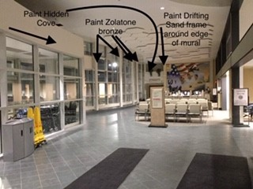

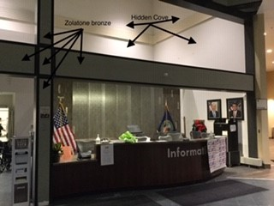

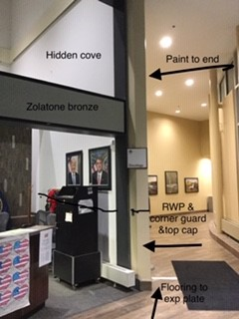

* Contractor shall provide and install approximately 8,000 square feet of wall protection as identified on attached drawing. Wall protection shall be 48” from floor base trim. Contractor shall provide and install approximately 2300 linear feet of wall protection trim to top of wall protection, trim shall be 2”. See attached finish schedule for wall protection specifications.
* Contractor shall remove existing corner guards and provide and install approximately 100 stainless steel corner guards. See attached drawing for corner guard locations. All corner guards must run from floor to ceiling. Corner guard specifications are located on attached finish schedule.
* Contractor shall demolish all existing crash rail and handrail.
* Contractor shall provide and install approximately 1600 linear feet of crash guard as identified in attached drawing and finish schedule. Crash guards stall be installed with the top of the rail 12 inches from floor.
* Contractor shall provide and install approximately 1600 linear feet of handrail in accordance with attached finish schedule and drawings. Hand rails shall be installed with top of handrail 36” from the floor.
* Contractor shall demolish existing and provide and install approximately 13,000 square feet of new ceiling tile and ceiling grid. See attached ceiling tile and grid specification.
* Contractor shall demolish existing, replace and install approximately 51 (2*4) new LED light fixtures, 5 (1*4) new LED light fixtures, and 3 (2*2) LED light fixtures in all corridors and waiting rooms identified in attached lighting replacement plan. Also see attached LED light specifications. Contractor will verify sizes and dimensions of all light fixtures to be replaced prior to replacement.
* Contractor shall resurface existing museum casework wood exterior utilizing 3M DI-NOC product, color, FW640. Contractor to coordination with 3M distributor to ensure proper installation occurs. Contractor shall remove interior casework shelving and brackets, patch holes and paint interior of museum spaces with finishes as indicated in finish schedule. See Inserted Pictures.

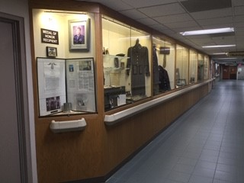

* Contractor shall resurface existing information desk located in F04A with 3M DI-NOC product, see attached finish schedule for color choices. Contractor to coordination with 3M distributor to ensure proper installation occurs. See attached picture below.

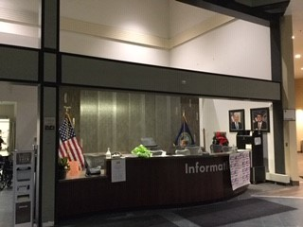

* Contractor to refinish existing counters at agent cashier window and pharmacy window in lobby B76. Agent cashier room number is B98. Counters shall be refinished in 3M DI-NOC product and counter brackets painted in drifting sand according to attached finish schedule. See attached picture below for counters that require refinishing.

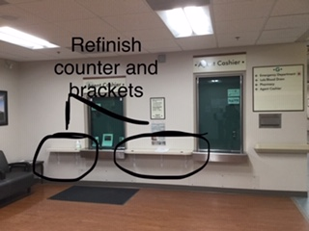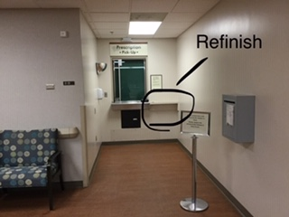

**Phase Two – 2nd and 3rd Floor CLC and Inpatient Med/Surg Units Building 5:**

Med/Surg Unit: Provision of and installation of wall protection for Building 5, 2nd and 3rd Floor Lobbies, Corridors and Inpatient Rooms of Med/Surgery Unit.

Med/Surg Areas:

* Lobbies 246 and 395
* Inpatient Corridors: 287, 287A, 394, 395A
* Inpatient Rooms: 203, 204, 205, 206, 207, 208, 230, 231, 232, 233, 234, 235, 236, 237, 303,304,305,306,307,308,334,335,336,337,338,339,340,341
* Family Waiting Rooms: 202, 302, 228
* Contractor shall provide and install approximately 8000 square feet of wall protection as identified on attached drawing. Wall protection shall be 48” from floor base trim. Contractor shall provide and install approximately 2000 linear feet of trim to top of wall protection, trim shall be 2”. See attached finish schedule for wall protection specifications.
* Contractor remove existing corner guards and provide and install approximately 125 new corner guards on 2nd floor and 125 corner guards on 3rd floor. See attached drawing for corner guard locations. All corner guards must run from floor to ceiling. Corner guard specifications are located on attached finish schedule.
* The contractor will be responsible for removing and reinstalling hand rails and crash rails during installation of wall paneling. Contractor shall be responsible to reinstall all wall mounted items that must be removed during installation of wall paneling.

CLC Unit: Demolition of existing flooring, floor preparation, and replacement flooring for all corridors, inpatient rooms and bathrooms. Wall covering removal, replacement wall covering, wall protection and paint. Removal of existing handrails/crash rails and replacement. Demolition of existing hallway alcove casework and wall repair. Provision and installation of 3M casework refinishing product for nurse’s stations, doors and wood accents. Contractor shall demolish current restroom finishes in all restrooms listed below and in attached drawing. Contractor shall install new tile on all bathroom floors and walls as specified in attached finish schedule. Contractor shall replace all existing lights to new LED lights as indicated in ceiling plan and attached lighting specifications. Contractor to provide and install new privacy curtains for all inpatient rooms as indicated in attached finish schedule. Contractor to provide and install new window treatments in all inpatient rooms. Contractor shall demolish existing window sills in all inpatient rooms and replace window sills in accordance with attached window sill specification. Contractor to provide and install new privacy curtains for each CLC2 and CLC3 inpatient room as indicated in attached finish schedule. Contractor shall sandblast and paint all existing steam vent covers in all inpatient CLC2 and CLC3 rooms.

CLC Areas:

* Corridors: 291-5, 396-5
* Nurse Areas: 288-5, 388-5
* CLC Common Areas: 256-5, 275-5, 361-5, 377-5
* CLC Inpatient Bathrooms: 248A-5, 249-5, 272A-5, 274A-5, 276A-5, 281A-5, 283A-5, 289A-5, 252A-5, 254A-5, 263A-5, 265A-5, 353A-5, 389A-5, 357A-5, 359A-5, 365A-5, 367A-5, 374A-5, 376A-5, 378A-5, 383A-5, 385A-5
* CLC Inpatient Rooms: 248-5, 272-5, 273-5, 274-5, 276-5, 281-5, 282-5, 283-5, 284-5, 289-5, 290-5, 252-5, 253-5, 254-5, 263-5, 264-5, 265-5, 266-5, 353-5, 389-5, 390-5, 357-5, 358-5, 359-5, 365-5, 366-5, 367-5, 368-5, 374-5, 375-5, 376-5, 378-5, 383-5, 384-5, 385-5, 386-5
* Contractor shall floor preparation in accordance with manufacturers standards for approximately 12,200 square feet of flooring on CLC2 and 12,200 square feet of flooring on CLC3. Contractor will be installing new Nora Flooring over existing flooring with manufacturers installation requirements. See attached installation specifications. Contractor shall provide and install approximately 12,200 square feet of flooring for CLC2 and 12,200 square feet of flooring for CLC3 for all corridors, inpatient rooms, common areas and waiting rooms as identified in attached CLC2 and CLC3 drawings and finish schedule. See attached finish schedule for flooring specifications. Flooring being installed is specified as Nora One flooring. This flooring requires a certified installer to ensure full warranty. It is required the contractor provide the full warranty on this flooring. This flooring requires special installation for floor preparation, installation, and after installation cleaning to ensure its longevity. Contractor shall reference the installation requirements for this floor at the following web address. <https://www.nora.com/global/en/installation-care-flooring>.

The Nora Valua flooring being installed on CLC’s will be installed over top of existing flooring utilizing the DryFix method from Nora with required flooring preparation which must be completed by a certified installer. No demo is needed of existing flooring as Nora flooring shall be installed over the top.

Contractor is required to buff and clean floor prior to turn over to government in accordance with cleaning and installation instructions.

* Contractor shall demolish all existing wall covering, remove adhesive and prepare walls for new wall covering, paint or wall protection as indicated in attached drawing and finish schedule. Contractor shall demolish approximately 20,870 square foot of existing wall covering, repair walls as required, including major wall repair if existing wall covering does not remove well, skim coat if required and provide new vinyl wall covering and paint as required on attached finish schedule.
* Contractor shall demolish existing casework in all alcoves down CLC2 and CLC3 hallways as depicted in below pictures. There are 19 casework alcoves on CLC2 and 19 alcoves on CLC3. Casework shall be removed and walls repaired, contractor to install wall protection 48” from floor with trim and paint from wall protection to ceiling. Stainless steel corner guards shall be installed on alcove corners.

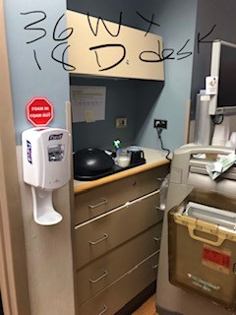

* Contractor shall refinish/wrap existing nurses station, all CLC inpatient room doors and bathroom doors and decorative columns on both CLC3 and CLC2 with 3M DINOC product. There are approximately 61 doors on CLC2 and 61 doors on CLC 3 that will require refinishing with the 3M DINOC product. The nurses station and decorative columns are approximately 1400 square feet of surface requiring refinishing with DI-NOC product. See attached CLC nurses station and alcove drawing and finish schedule for product specifications.

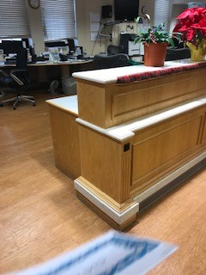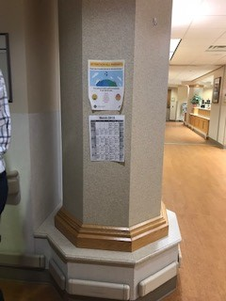

* Contractor shall sandblast and repaint approximately 76 steam vent covers in all CLC2 and CLC3 inpatient rooms. See attached finish schedule for color specifications.
* Contractor shall refinish snack stations, two existing casework stations on CLC2 and two existing casework stations on CLC3. All casework for each station shall be refinished in 3M DI-NOC product. Color specifications in attached finish schedule under nurses station finishes. Counter tops of each casework station shall be removed and new counters shall be installed using product specified in finish schedule. Contractor to reuse existing sink and faucets at each snack station. See pictures below of snack stations. Approximately 300 square feet of casework shall be resurfaced.

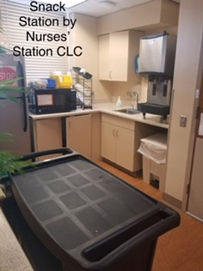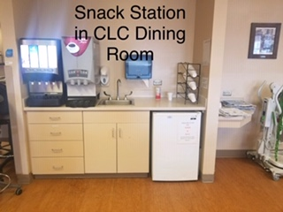

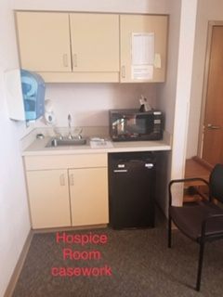

* Contractor shall demolish all existing flooring and tile around sinks in CLC inpatient restrooms listed above and on attached CLC2 and CLC3 bathroom drawing. Contractor shall install new tile on floor and on walls from floor to ceiling. Tile design and specifications can be found in attached finish schedule. Contractor shall install new bathroom light fixtures above sinks in accordance with light finish schedule. Contractor shall protect and reuse existing sink, mirror, toilet paper dispensers, paper towel, glove dispensers and grab bars. There are approximately 11 restrooms on CLC2 and 11 restrooms on CLC3.

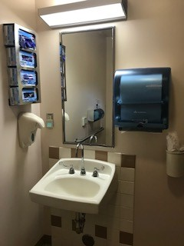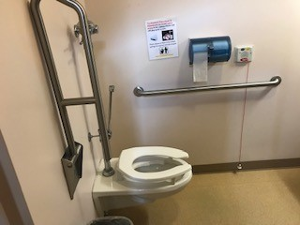

* Contractor shall provide and install approximately 1792 linear feet of crash guard on CLC2 and CLC3 as identified in attached drawing and finish schedule. Crash guards stall be installed with the top of the rail 12 inches from floor.
* Contractor shall provide and install approximately 1792 linear feet of handrail on CLC2 and CLC3 in accordance with attached finish schedule and drawings. Hand rails shall be installed with top of handrail 36” from the floor.
* Contractor shall demolish all tile around sinks in inpatient rooms and repair wall. Wall protection should be placed around sink as indicated in wall protection drawing. Picture of tile to be demolished show below.

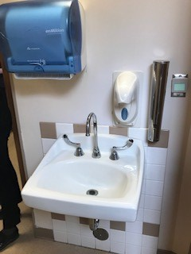

* Contractor shall provide and install approximately 16696 square feet of wall protection as identified on attached drawing. Wall protection shall be 48” from floor base trim. Contractor shall provide and install approximately 4174 linear feet of acrovyn trim to top of wall protection, trim shall be 2”. See attached finish schedule for wall protection specifications.
* Contractor remove existing corner guards and provide and install approximately 100 newcorner guards on 2nd floor and 100 corner guards on 3rd floor. See attached drawing for corner guard locations. All corner guards must run from floor to ceiling. Corner guard specifications are located on attached finish schedule.
* Contractor shall demolish approximately 53 window sills and window coverings on CLC2 and 53 window sills and window coverings on CLC3. Contractor shall provide and install new window sills and window coverings in accordance with attached finish schedule. Contractor to measure and verify all sizes of window coverings and sills prior to ordering and installation.
* Contractor shall provide and install new privacy curtains in all CLC inpatient rooms. Curtains shall be approximately 66” *66” wide. Approximately 420 curtains are required for all inpatient rooms. See attached finish schedule for color and pattern. Contractor shall also provide snap panel curtain mesh in the following sizes: 124” * 20” approximately 105 quantity needed and 66” *20” approximately 24 quantity needed.
* Contractor shall paint all cabinetry in CLC2 and CLC3 inpatient rooms above closets in accordance with finish schedule color specifications. See below picture for reference. There are approximately 45 upper cabinets that will need to be painted.

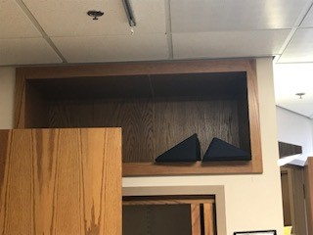

* Contractor shall replace approximately 116 (2*4) LED lights, 70 (1*4) LED lights, 36 (Inpatient Bathroom Vanity) lights, 22 (6” LED can lights) and 22 (Inpatient Room Vanity Lights). See attached lighting replacement plan that identifies quantities and description of lights to be replaced by room number.
* Contractor shall demolish, and replace approximately 10,700 square feet on CLC2 and 10,700 square feet on CLC3 of ceiling tile and ceiling grid. See attached ceiling grid replacement plan and finish schedule for ceiling tile plan and specifications.

**Phase Three (Fourth Floor, Building 5):** Demolition of existing flooring, floor preparation, and replacement flooring. Wall covering removal, replacement wall covering, wall protection and paint. Removal of existing handrails/crash rails and replacement. Provision of and installation of new ceiling grid and ceiling tiles. Provision of an installation of new window sills and window shades. Provision and installation of new impact resistant doors. Provision of and installation of new LED lighting for the following areas on 4th Floor, Building 5:

* Lobby: 485
* Corridors: 487, 488, 484, 483, 483A
* Waiting Rooms: 473, 445, 403, 408
* Check-In Room: 401
* Window Shades and window sills in the following Rooms will be demolished and replaced in the following rooms: 480, 478, 477A, 477B, 477C, 477D, 447E, 447G, 447H, 475, 473, 472, 471, 470, 469, 468, 467, 466, 465, 464A, 464C, 464B, 463B, 463C, 463A, 462, 461, 460, 459, 458, 457A, 455, 451, 450, 449, 448, 447A, 447, 446A, 403, 408, 401. See attached finish schedule for specifications. There are approximately 46 windows that need new window sills and window coverings.

Contractor is required to field verify all window sill sizes prior to ordering and installation. Contractor is also required to field verify all window covering sizes prior to ordering and installation.

* Contractor shall refinish/wrap 4th floor exam room doors and bathroom doors with 3M DI-NOC product. There are approximately 75 doors on 4th floor that will require refinishing with the 3M DINOC product. In addition, contractor shall sand and repaint all door frames for each door being replaced. Paint specification and color in attached finish schedule.
* Contractor shall refurbish approximately 5 existing tile alcoves in the 4th floor corridors. See attached 4th floor alcove refurbish drawing for locations of alcoves. Contractor shall demolish existing tile in each alcove and replace with new tile as specified in finish schedule. Contractor shall refinish existing cabinetry with 3M Di-NOC product as indicated in attached finish schedule. Contractor shall replace existing solid surface counters in each alcove with new solid surface as referenced in attached finish schedule. Each alcove is approximately 3 feet deep and 3 feet wide and 7 feet tall. Approximately 64 square feet of space for each alcove.
* Contractor shall replace existing accordion wall at 401 check-in room with new wood fold accordion wall. Contractor shall demolish existing and provide and install new accordion wall. Contractor shall be responsible for working with vendor to procure accurate size accordion wall with locking capabilities and installing in accordance with manufactures recommendations. Contractor shall reference attached finish schedule for product specifications and 4th floor accordion wall drawing for location reference.

Product Specifications can be found at:

<https://woodfold.com/accordion/>

<https://woodfold.com/pdf/accordion/Woodfold-Accordion-16pg-2010-WAC10.pdf>

Vendor:  Woodfold

Series:  440 / Security Accordion Doors

Specified Color:  Bronze hardware/Bronze acrylic panel

* Contractor shall provide demolition, removal and floor preparation for approximately 6,000 square feet of flooring. Contractor shall provide and install approximately 6000 square feet of flooring for all corridors and waiting rooms as identified in attached drawings and finish schedule. See attached finish schedule for flooring specifications.
* Contractor shall install flooring in required design pattern shown below for the transition between corridor 484-5 to lobby 485-5. VA is matching pattern on 2nd and 3rd floor lobbies of building 5. See below pictures for design reference. Also see attached 1st floor flooring design.

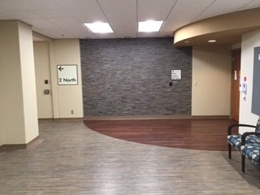 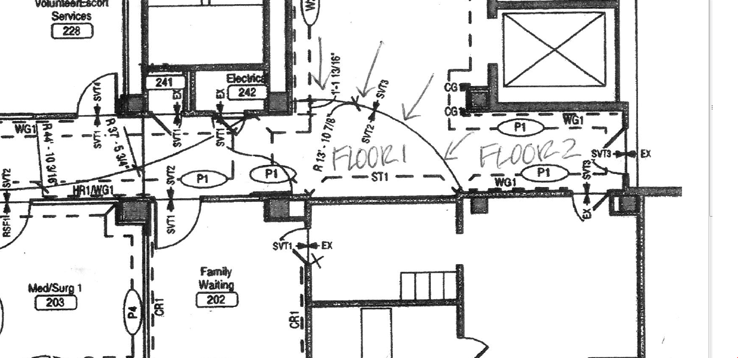

* Contractor shall demolish existing and provide and install approximately 1300 line
* Contractor shall demolish existing and provide and install approximately 1360 linear feet of vinyl base trim. See attached finish schedule for product specifications.
* Contractor shall demolish all existing wall covering, remove adhesive and prepare walls for new wall covering, paint or wall protection as indicated in attached drawing.

Contractor shall demolish approximately 11500 square foot of existing wall covering, repair walls as required, including major wall repair if existing wall covering does not remove well, skim coat if required and provide new vinyl wall covering and paint as required on attached finish schedule.

* Contractor shall provide and install approximately 5400 square feet of wall protection as identified on attached drawing. Wall protection shall be 48” from floor base trim. Contractor shall provide and install approximately 1360 linear feet of wall protection trim to top of wall protection, trim shall be 2”. See attached finish schedule for wall protection specifications.
* Contractor remove existing corner guards and provide and install approximately 75 new corner guards. See attached drawing for corner guard locations. All corner guards must run from floor to ceiling. Corner guard specifications are located on attached finish schedule.
* Contractor shall demolish all existing crash rail and handrail.
* Contractor shall provide and install approximately 1360 linear feet of crash guard as identified in attached drawing and finish schedule. Crash guards stall be installed with the top of the rail 12 inches from floor.
* Contractor shall provide and install approximately 1360 linear feet of handrail in accordance with attached finish schedule and drawings. Hand rails shall be installed with top of handrail 36” from the floor.
* Contractor shall demolish existing and provide and install approximately 6,000 square feet of new ceiling tile and ceiling grid. See attached ceiling tile and grid specification.
* Contractor shall demolish existing, replace and install approximately 64 new LED light fixtures in all corridors and waiting rooms identified in attached lighting plan. Contractor shall replace 34 (2*4) LED light fixtures and 30 (1*4) LED light fixtures. See attached LED light specification.

**Phase Four (First Floor, Building 5 & Connecting Corridor):** Demolition of existing flooring, floor preparation, and replacement flooring. Wall covering removal, replacement wall covering, wall protection and paint. Removal of existing handrails/crash rails and replacement. Provision of and installation of new ceiling grid and ceiling tiles. Demolition of old window shades and window sills and provision of an installation of new window sills and window shades. Demolition of old doors and provision and installation of new high impact doors, doors only, not hardware or frames. Painting of existing door frames. Sandblast and painting of existing steam vent covers. Provision of and installation of new lighting for the following areas on 1st Floor, Building 5: 1st Floor, Building 5 Main Lobby (184), Corridors (186, 132). Connecting corridor (187)

* Contractor to sandblast and repaint approximately 17 steam vent covers in connecting corridor 187 as indicated in attached finish schedule.
* Contractor to replace approximately 17 window sills and window shades in connecting corridor 187. See attached finish schedule for window sill and window shade specifications.
* Contractor shall remove existing doors and furnish and install approximately 53 new high impact doors (20 minute rated interior doors), 2 new (3-hour fire rated) doors, and 1 new (1.5 hour fire rated doors). See attached 1st floor door plans showing which doors will be replaced. Contractor shall reference attached finish schedule and door specification attachments. Door replacement includes door only, no frames or hardware. Contractor is required to reuse existing door hardware. Install existing hardware on new doors and ensure functionality. If existing door had a window the new door ordered should match and have a window as well. Contractor shall measure and verify all door sizes, match existing swing and door details. Contractor shall also ensure existing hardware will function on new door and verify they have ordered the correct fire rating prior to ordering and installation. In addition, contractor shall sand and repaint all door frames for each door being replaced. Paint specification and color in attached finish schedule.
* Contractor shall provide demolition, removal and floor preparation for approximately 5,500 square feet of flooring. Contractor shall provide and install approximately 5,500 square feet of flooring for all corridors and waiting rooms as identified in attached drawings and finish schedule. See attached finish schedule for flooring specifications.
* Contractor shall install flooring in required design pattern shown below for the transition between corridor 132-5 to lobby 184-5. VA is matching pattern on 2nd and 3rd floor lobbies of building 5. See below pictures for design reference. Also see attached 1st floor flooring design drawing.

 

* Contractor shall demolish existing and provide and install approximately 1300 linear feet of vinyl base trim. See attached finish schedule for product specifications.
* Contractor shall demolish all existing wall covering, remove adhesive and prepare walls for new wall covering, paint or wall protection as indicated in attached drawing.

Contractor shall demolish approximately 12000 square foot of existing wall covering, repair walls as required, including major wall repair if existing wall covering does not remove well, skim coat if required and provide new vinyl wall covering and paint as required on attached finish schedule.

* Contractor shall provide and install approximately 5400 square feet of wall protection as identified on attached drawing. Wall protection shall be 48” from floor base trim. Contractor shall provide and install approximately 1300 linear feet of acrovyn trim to top of wall protection, trim shall be 2”. See attached finish schedule for wall protection specifications.
* Contractor remove existing corner guards and provide and install approximately 50 new acrovyn corner guards. See attached drawing for corner guard locations. All corner guards must run from floor to ceiling. Corner guard specifications are located on attached finish schedule.
* Contractor shall demolish all existing crash rail and handrail.
* Contractor shall provide and install approximately 1300 linear feet of crash guard as identified in attached drawing and finish schedule. Crash guards stall be installed with the top of the rail 12 inches from floor.
* Contractor shall provide and install approximately 1300 linear feet of handrail in accordance with attached finish schedule and drawings. Hand rails shall be installed with top of handrail 36” from the floor.
* Contractor shall demolish existing and provide and install approximately 5,500 square feet of new ceiling tile and ceiling grid. See attached ceiling tile and grid specification.
* Contractor shall demolish existing, replace and install approximately 47 new LED light fixtures in all corridors and waiting rooms identified above. Contractor shall install approximately 25 (2*4) LED light fixtures and 22 (1*4) LED light fixtures. See attached LED light specification.
* Contractor shall provide digital printed acrovyn decorative panels for the wall covering in the connecting corridor 187. Approximately 10 digitally printed decorative panels will be provided and installed by the contractor. The VA interior designer will send digital prints to contractor for printing purposes. Contractor will measure verify panel sizes with subcontractor. Contractor shall include cost of printing, provision and installation as part of this contract. Panels to be installed above wall protection: (i.e. Base to 48” high will be wall protection and wall protection trim, decorative panel to be installed from top of trim to ceiling.)

**Mock-up Wall Requirement**

Contractor during submittal process shall submit a mock up demonstration drawing that shows all wall products and hang locations to ensure proper heights are done for wall covering, base, handrail and crash rail. This shall be approved prior to work starting.

**Other Minimum Specifications and Requirements:**

In addition to manufacturer warranties; contractor shall provide a 1 year warranty from date of final acceptance for installation and all work.

Contractor will deliver flooring and adhesives in original wrappings and packages clearly labeled with manufacturer’s name or brand, type and color, production run number and date of manufacture.

Materials from containers which have been distorted, damaged, opened or are beyond manufacturer’s shelf life prior to installation will be rejected.

Storage of materials in areas designated by the COR at the Sioux Falls Regional Office is permitted at the contractor’s risk. The storage and its security must be provided by the contractor. Storage areas must be approved by the COR.

Material and adhesives shall condition to room temperature for a minimum of 48 hours before starting the installation.

The contractor shall use adhesives, and underlayment recommended by the floor material manufacturer.

Adhesives shall comply with applicable regulations regarding toxic and hazardous materials Green Seal (GS-36) for commercial adhesive.

Low-VOC adhesives and materials shall be used during the installation process.

Adhesives shall be applied uniformly with no bare spots.

Edge strips shall be located under center line of doors unless otherwise shown

Resilient edge strips shall be set in adhesive.

Edge strip shall butt to touch along tile edge where tile edge is exposed.

Edge strips shall bevel from maximum thickness to minimum thickness for flush joint unless shown otherwise.

The contractor shall remove any existing carpet, tile, vinyl flooring and base trim prior to installation of floor covering.

**Floor Preparation:**

The contractor shall inspect the sub-flooring before installation of any floor covering takes place and correct any deficiencies in the floor that will prevent proper lying of floor covering. Any detected deficiencies shall be reported to the COR immediately prior to any work being accomplished.

The contractor shall correct any conditions which will impair proper installation.

The contractor shall fill cracks, joints, and other irregularities in concrete sub-floor with leveling compound:

* + Contractor shall not use adhesive for filling or leveling purposes
  + Contractor shall not use leveling compound to correct imperfections which can be corrected by spot grinding
  + Contractor shall trowel to smooth surface free of trowel marks, pits, dents, protrusions, cracks or joints.

All proposed flooring areas shall be prepared for flooring installation as required by each products specified exact installation requirements. Floor must be clean of oil, paint, dust, and deleterious substances: leave floor dry and cured free of residue from existing curing or cleaning agents.

Concrete subfloor shall be primed if it will seal slab conditions that would inhibit bonding, or if priming is recommended by the tile or adhesive manufacturers.

Contractor shall comply with flooring manufacturer’s written instructions for substrate temperature, ambient temperature, moisture, ventilation, and other conditions affecting flooring application.

Contractor shall ensure all walls are free of any residual glue or adhesive and prepared for primer and paint.

Preparation of existing installation shall include the removal of existing flooring, base, wallcovering, tile and adhesive. Solvents shall not be used to remove adhesives.

Existing adhesive residue shall be removed so that 100% of the overall area of the original substrate is exposed.

\

**Flooring Installation:**

Installation shall be in accordance with manufacturer’s instructions for application and installation unless specified otherwise.

Tile shall be mixed from at least two containers. An apparent line either of shades or pattern variance will not be accepted.

Tiles shall be trimmed to touch for the length of intersections at pipes and vertical projections. Joints shall be sealed at pipes with waterproof cement.

Exposed adhesive is not acceptable.

Project phasing shall be determined by mutual agreement between Sioux Falls VA and contractor.

Prior to acceptance, contractor shall replace any damaged carpet tiles or vinyl base.

The contractor shall remove and dispose of all existing systems furniture. Contractor shall work with systems furniture contractor to coordinate phasing and installation.

Contractor will maintain walkways where required and remove debris each night, keeping dust to a minimum. They will provide a dumpster to be parked on VA grounds at a designated parking area.

Contractor shall vacuum carpet and provide suitable protection. Do not use polyethylene film.

Contractor shall be experienced in applying specified floor coverings that are similar in material, design, and extent to those indicated for this project.

The contractor is responsible for ensuring the quality of all work performed, subject to terms of “warranty of construction” FAR clause 52.246-21.

**Material for Owner Stock**

Contractor shall return to the government any material stock left over after job completion to the government for storage as owners stock/government property. This includes, flooring, base, wall covering, trim, wall covering, handrails and crash rails.

**Ceiling Grid and Tile Specifications:**

Contractor shall use Cortega Ceiling Tile and suspension system. Item Number 704. Dimensions 2’ x 2’ x 5/8”. Class A Fire Rated, Light Reflection .82, Acoustical Rating .55.



**LED Light Specifications:**

Manufacturer:

Part Numbers: The part number for the LED 2x4 troffers is 24CZ-LD4-40-UNV-840-CD1-U and the 2x2 troffer is 22CZ-LD4-24-UNV-L840-CD1-U. Inserted is the specification for the troffers.



**Product Specification Documents:**

Contractor shall reference the attached product specification documents for all products listed in the finish schedule for installation requirements and cleaning requirements.

Attachment 1: Toilet Partitions Specification Sheet

Attachment 2: Nu-Tree Wall Guard Specification Sheet (Crash Rail Specification)

Attachment 3: Wall Protection and Corner Guard Installation and Cleanup Instructions

Attachment 4: Acrovyn Door Specification

Attachment 5: Nora Flooring Specifications for Cleaning, Installation and Floor Preparation

Attachment 6: 3M DI-NOC Product Specifications (This product requires certified installation technician).

Attachment 7: Interior Design Finish Materials Basis of Design Document – Contractor can use this document to view all specified materials referenced in finish schedule.